Hi Team, I have taken screenshot of each step in our project assignment and added in the below document.

**Host a Website on Amazon Web Services**

Step 1: Configure a Virtual Private Cloud (VPC)

* Create a VPC with a Single Public Subnet option

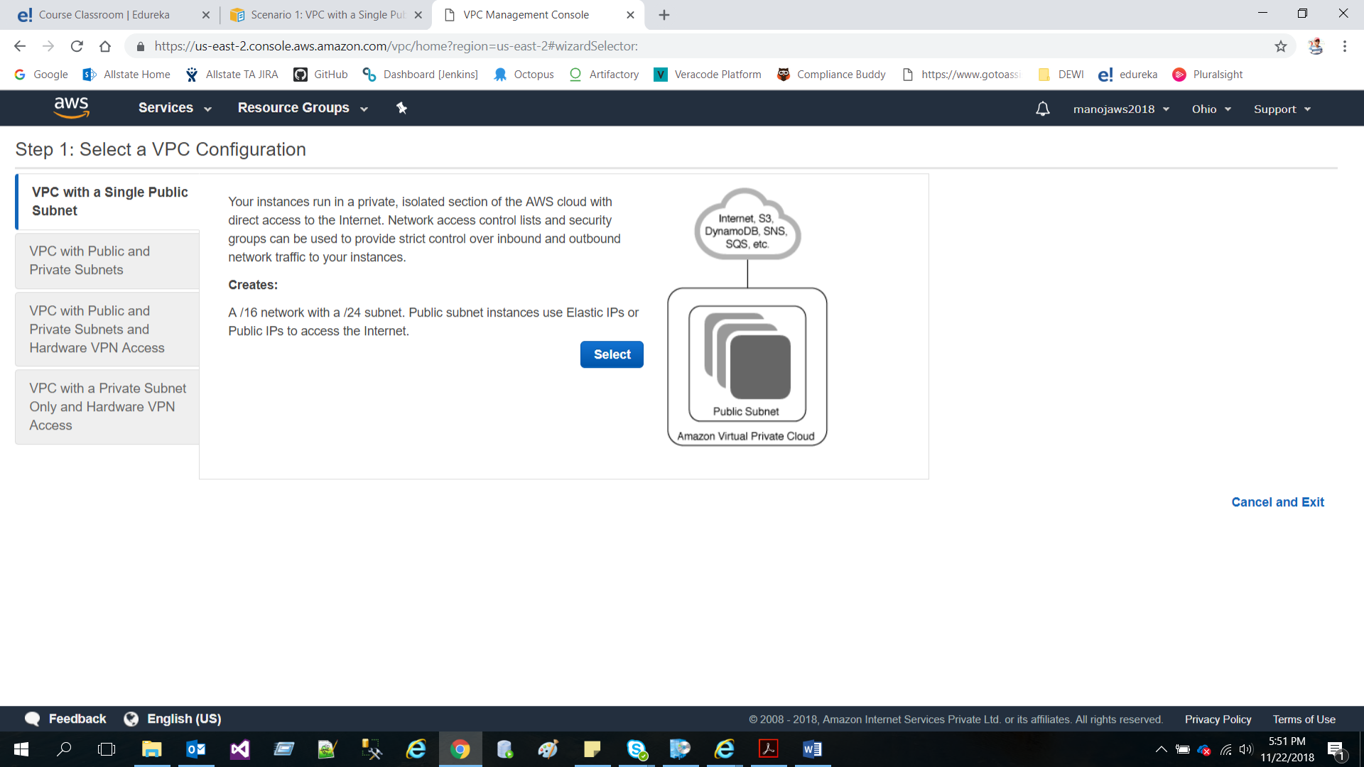

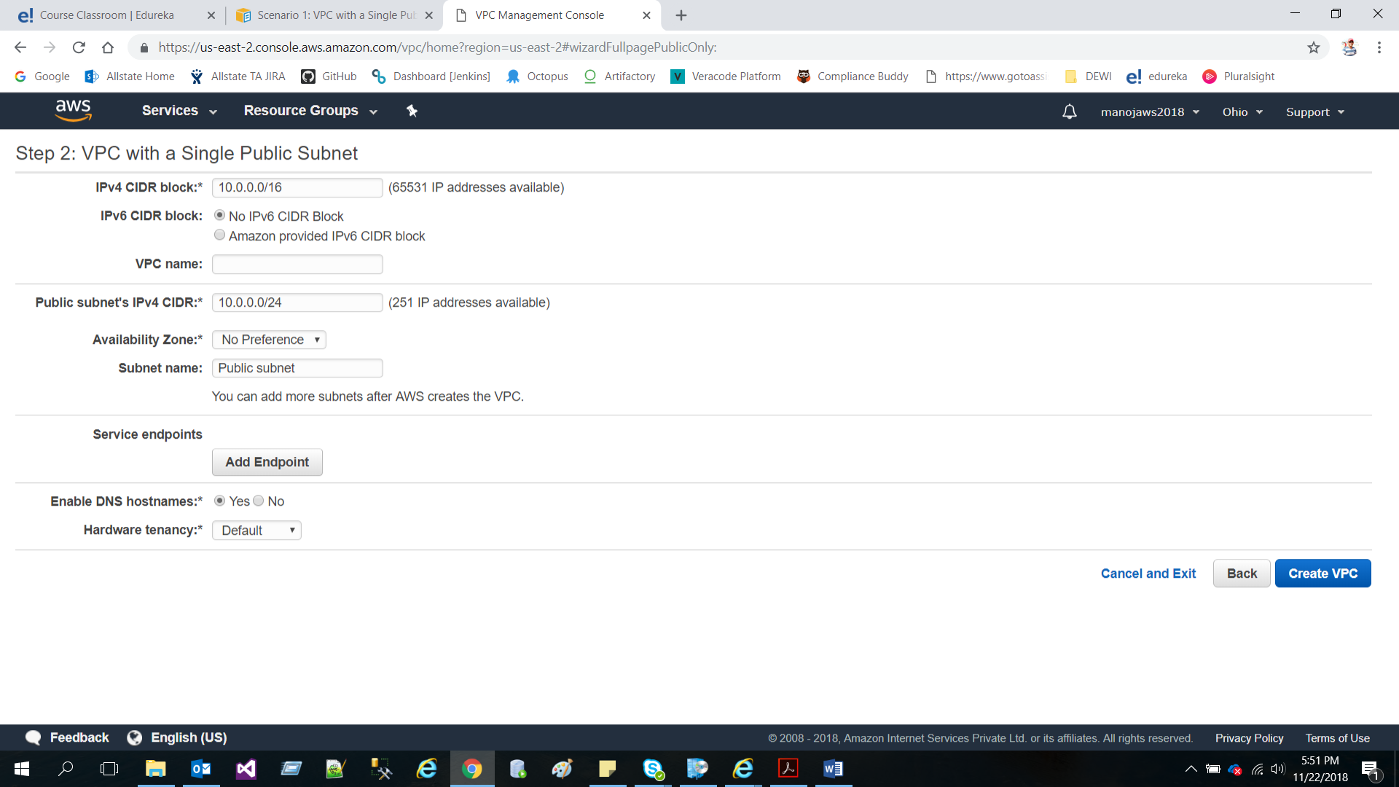

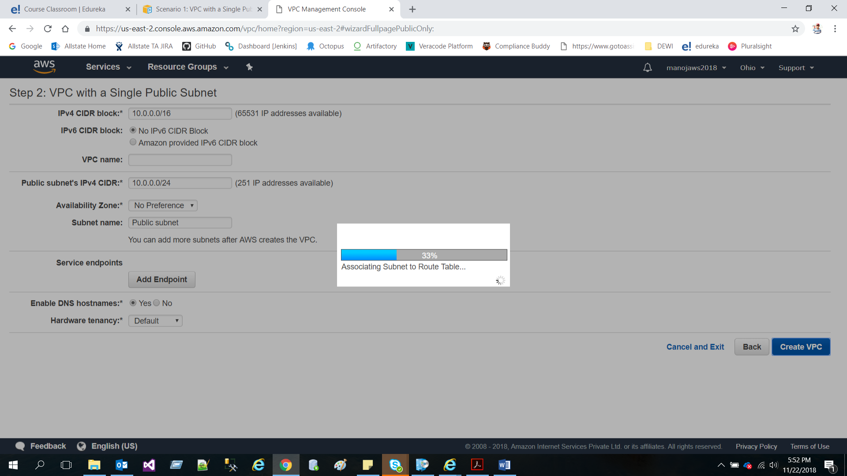

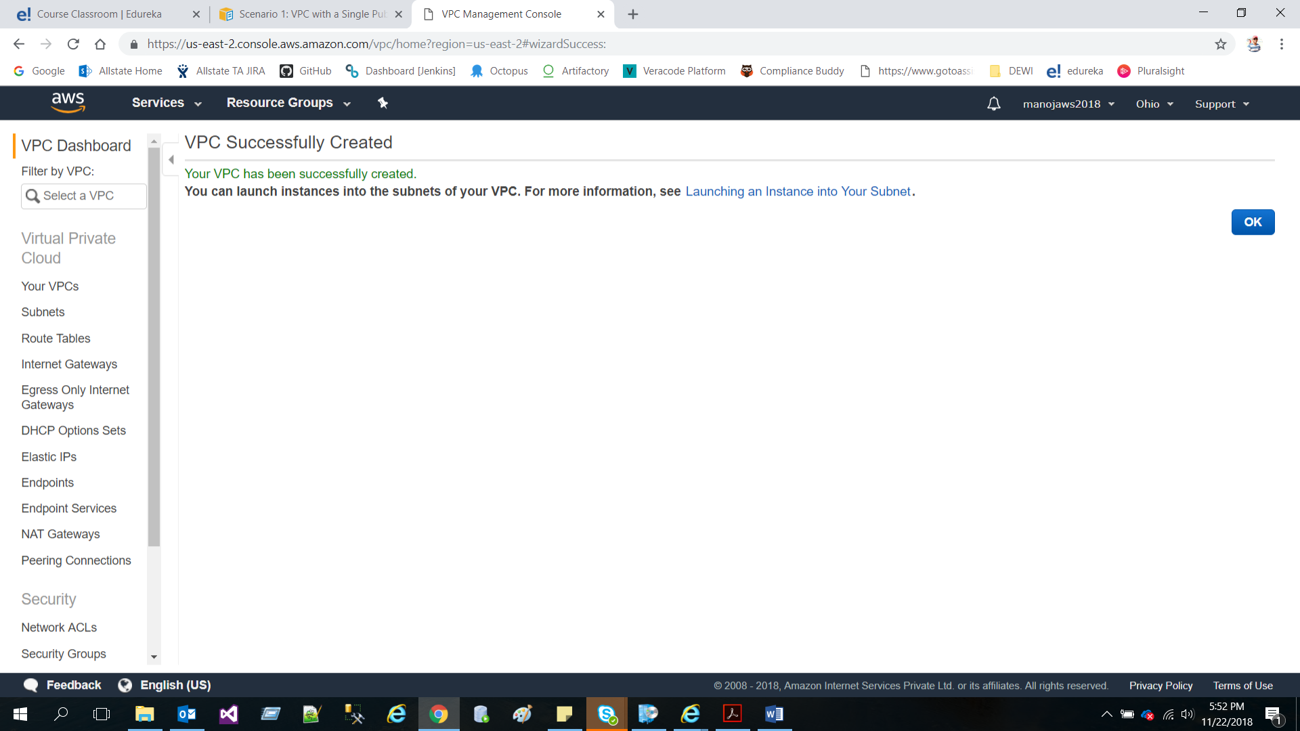

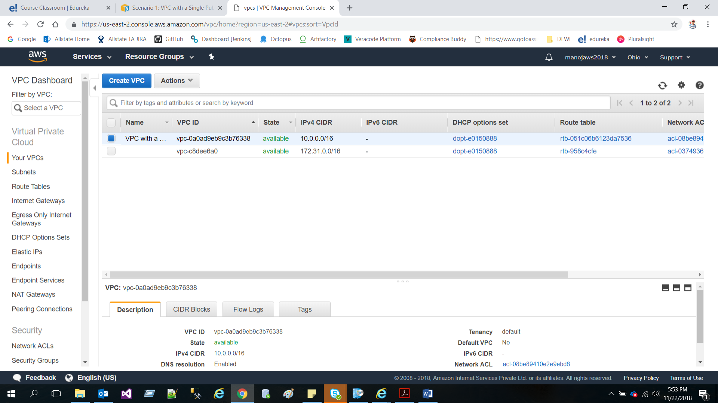

* Create a public subnet for your load balancer in two Availability Zones

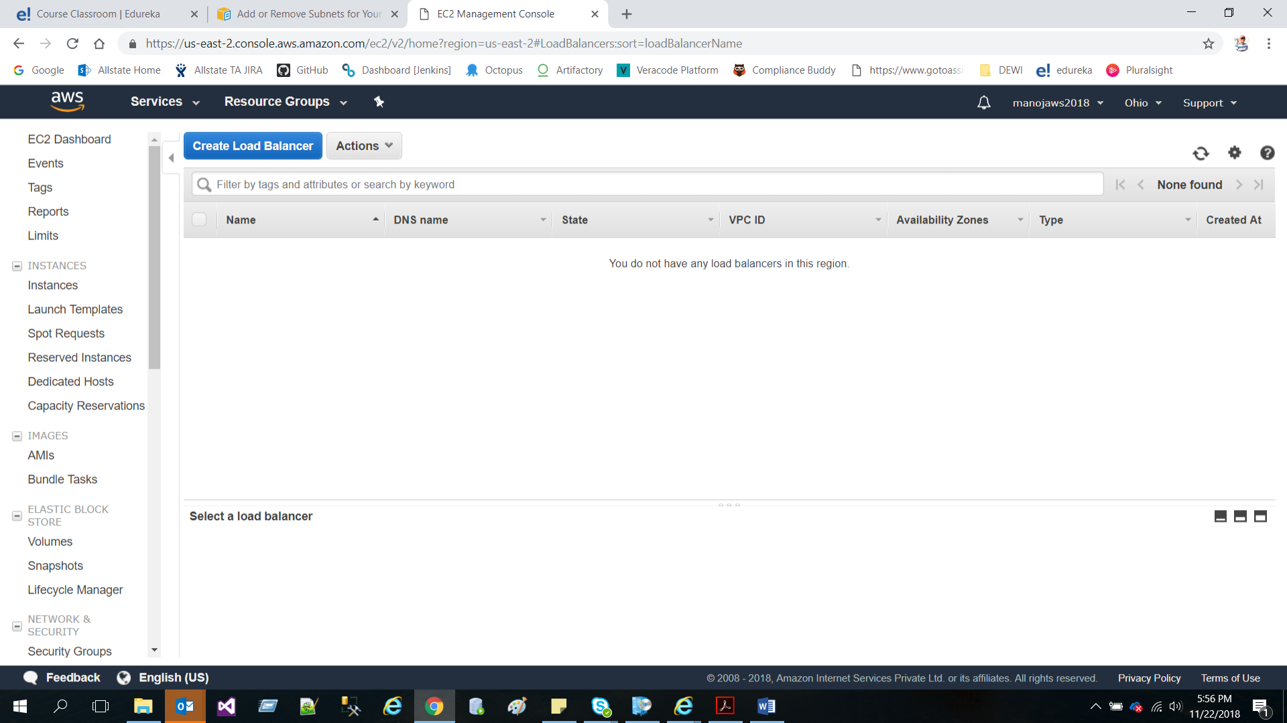

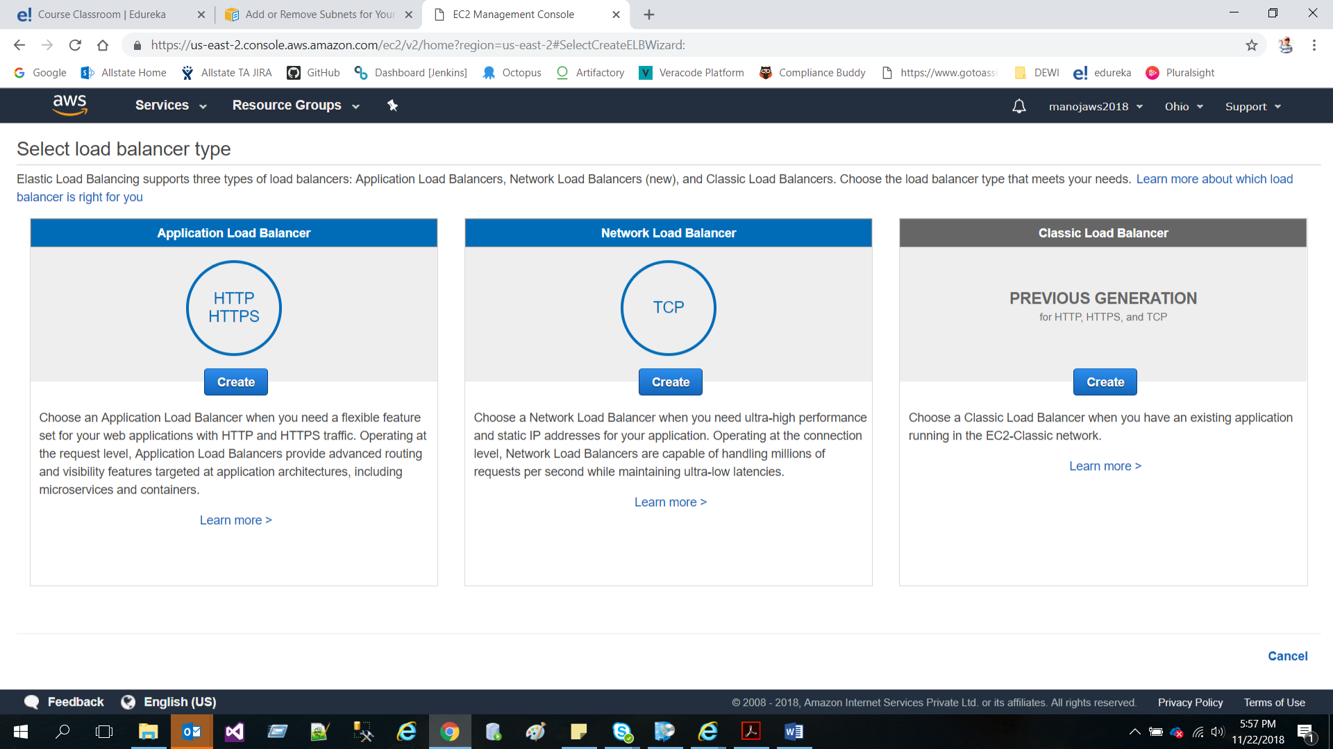

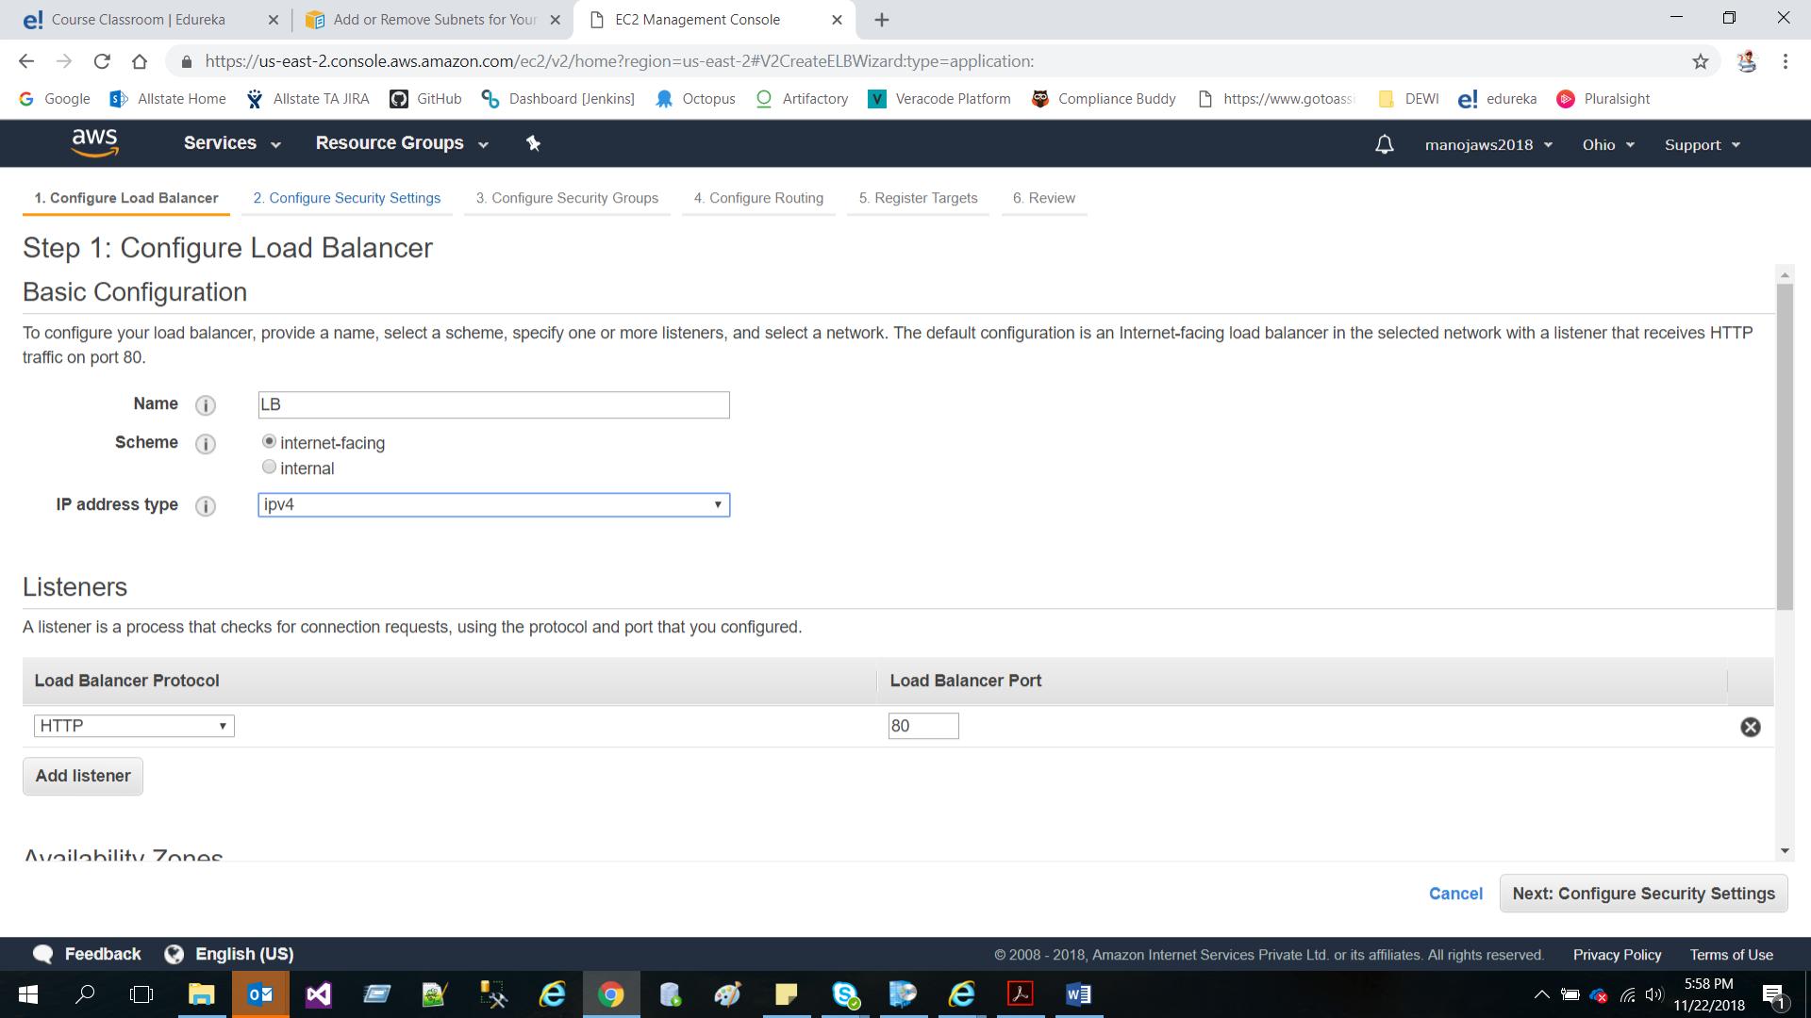

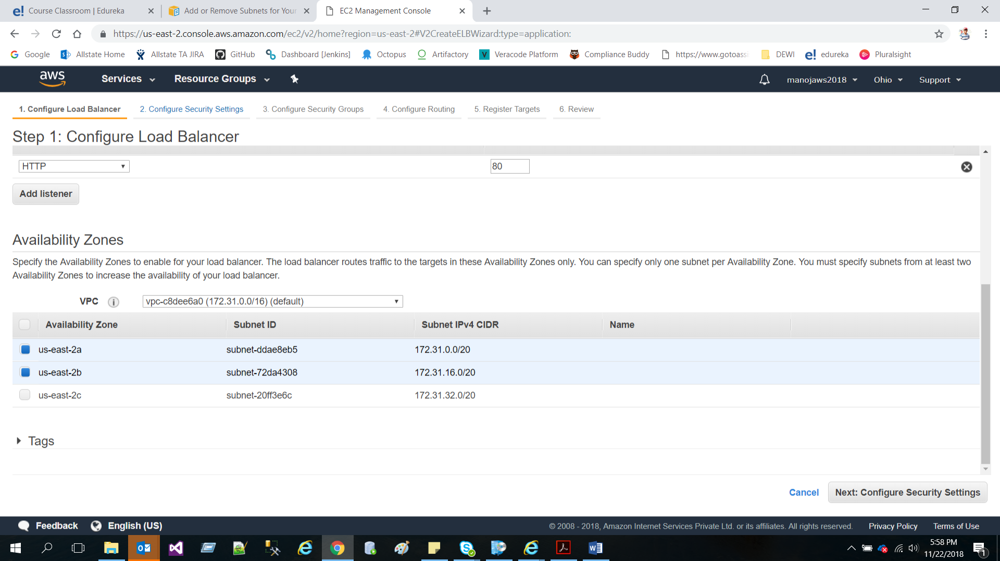

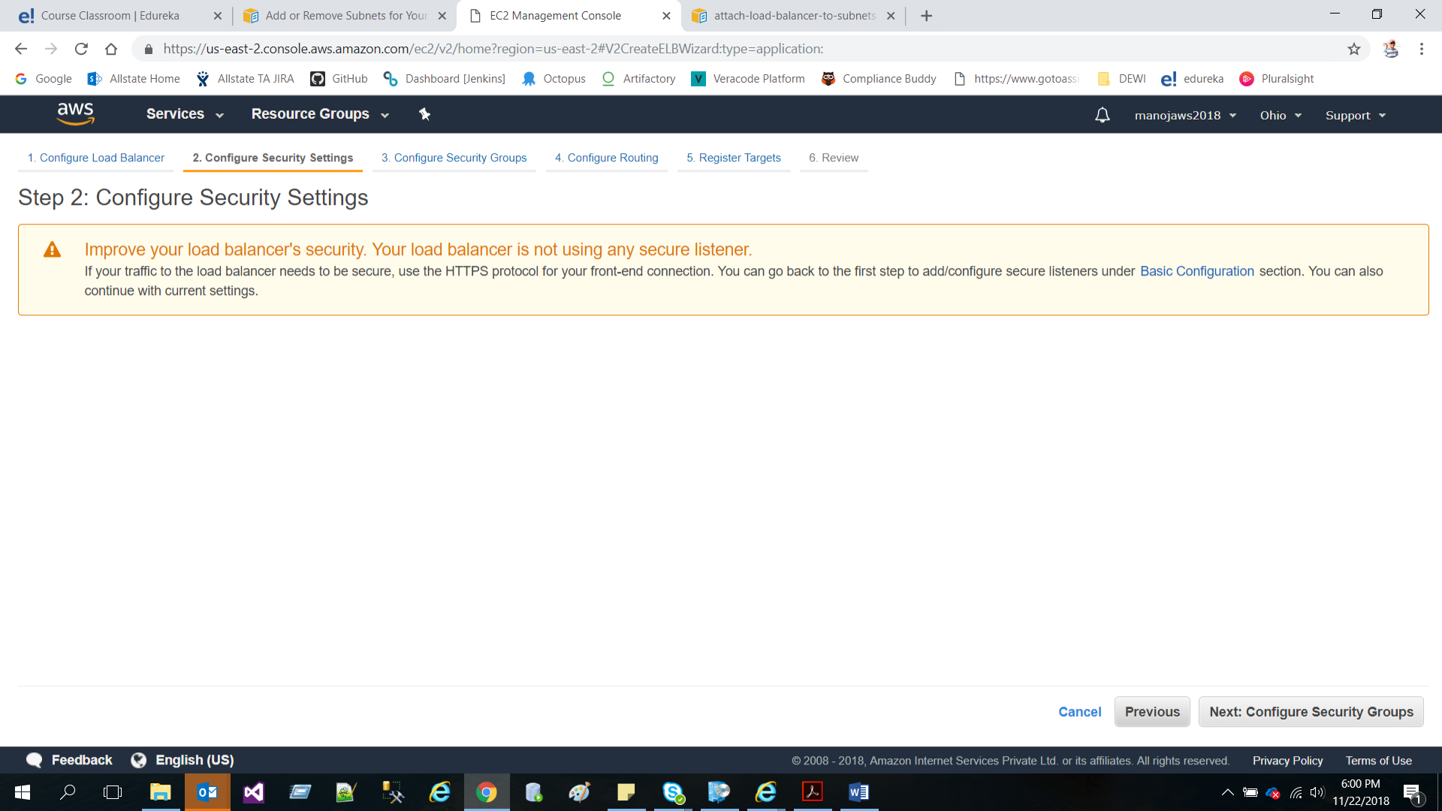

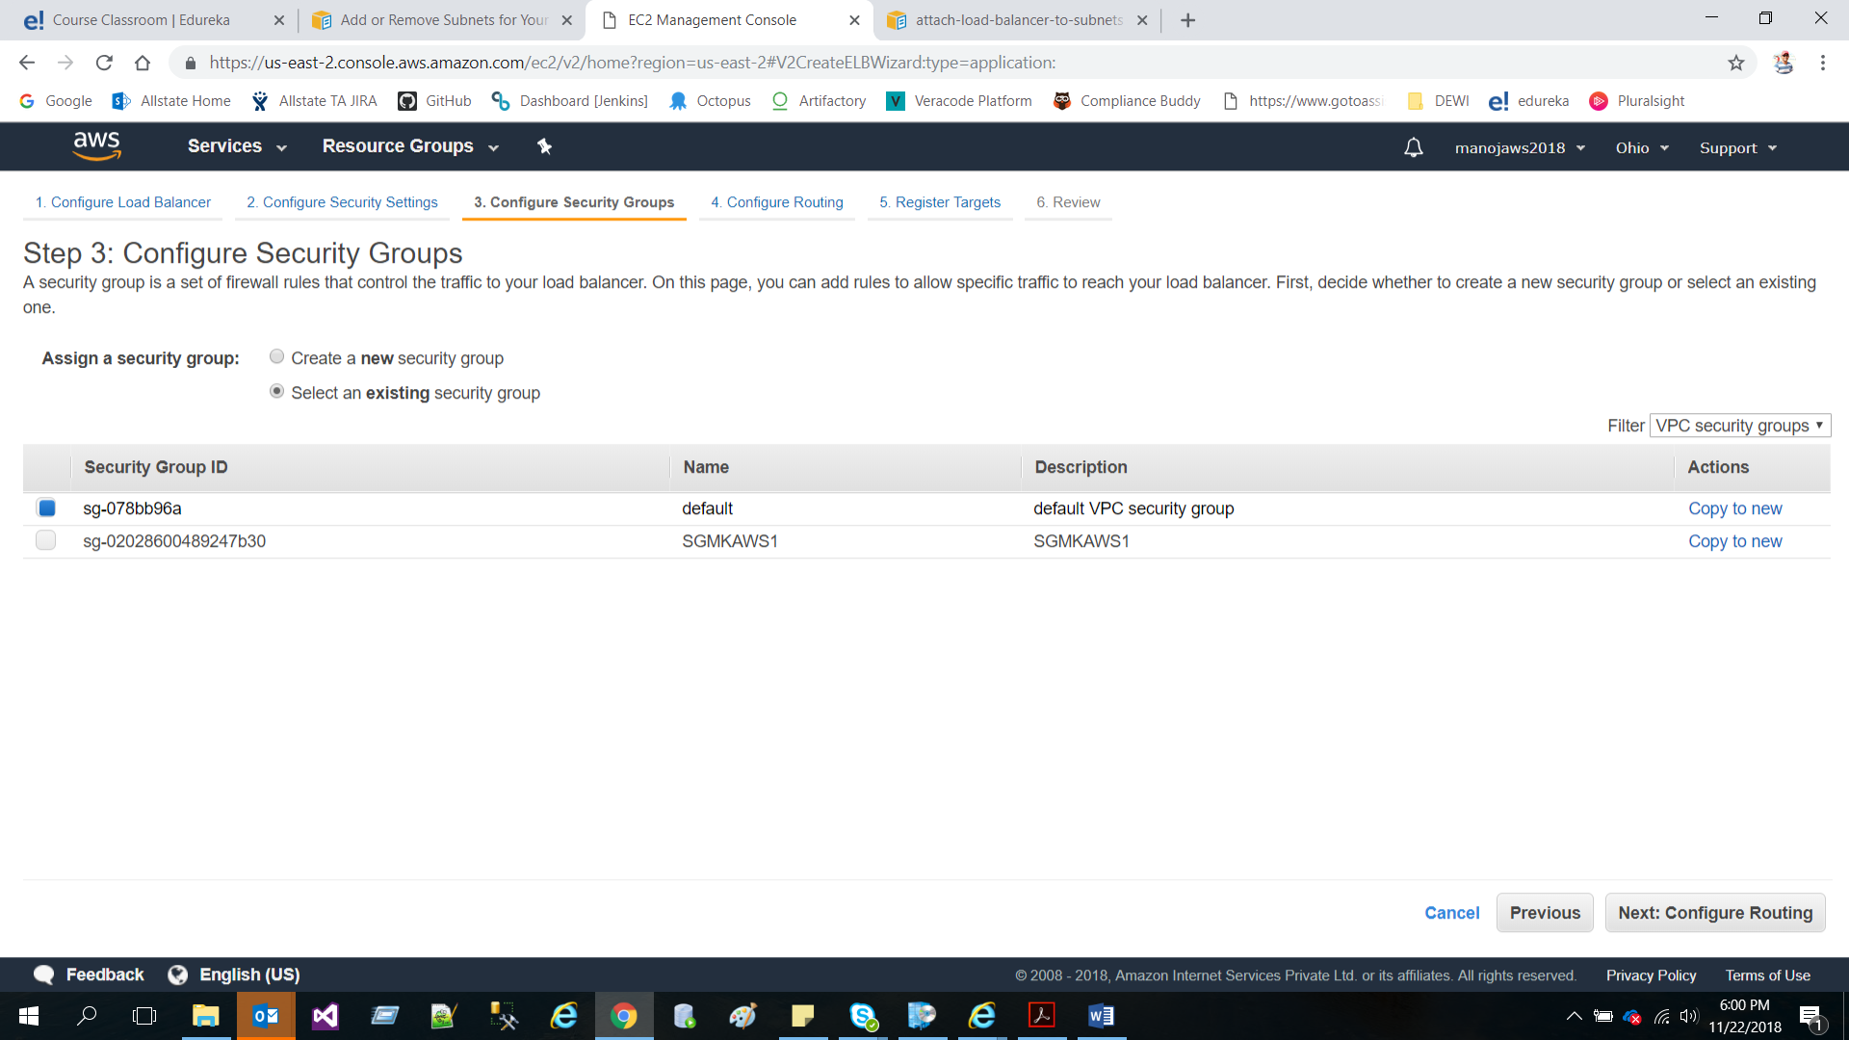

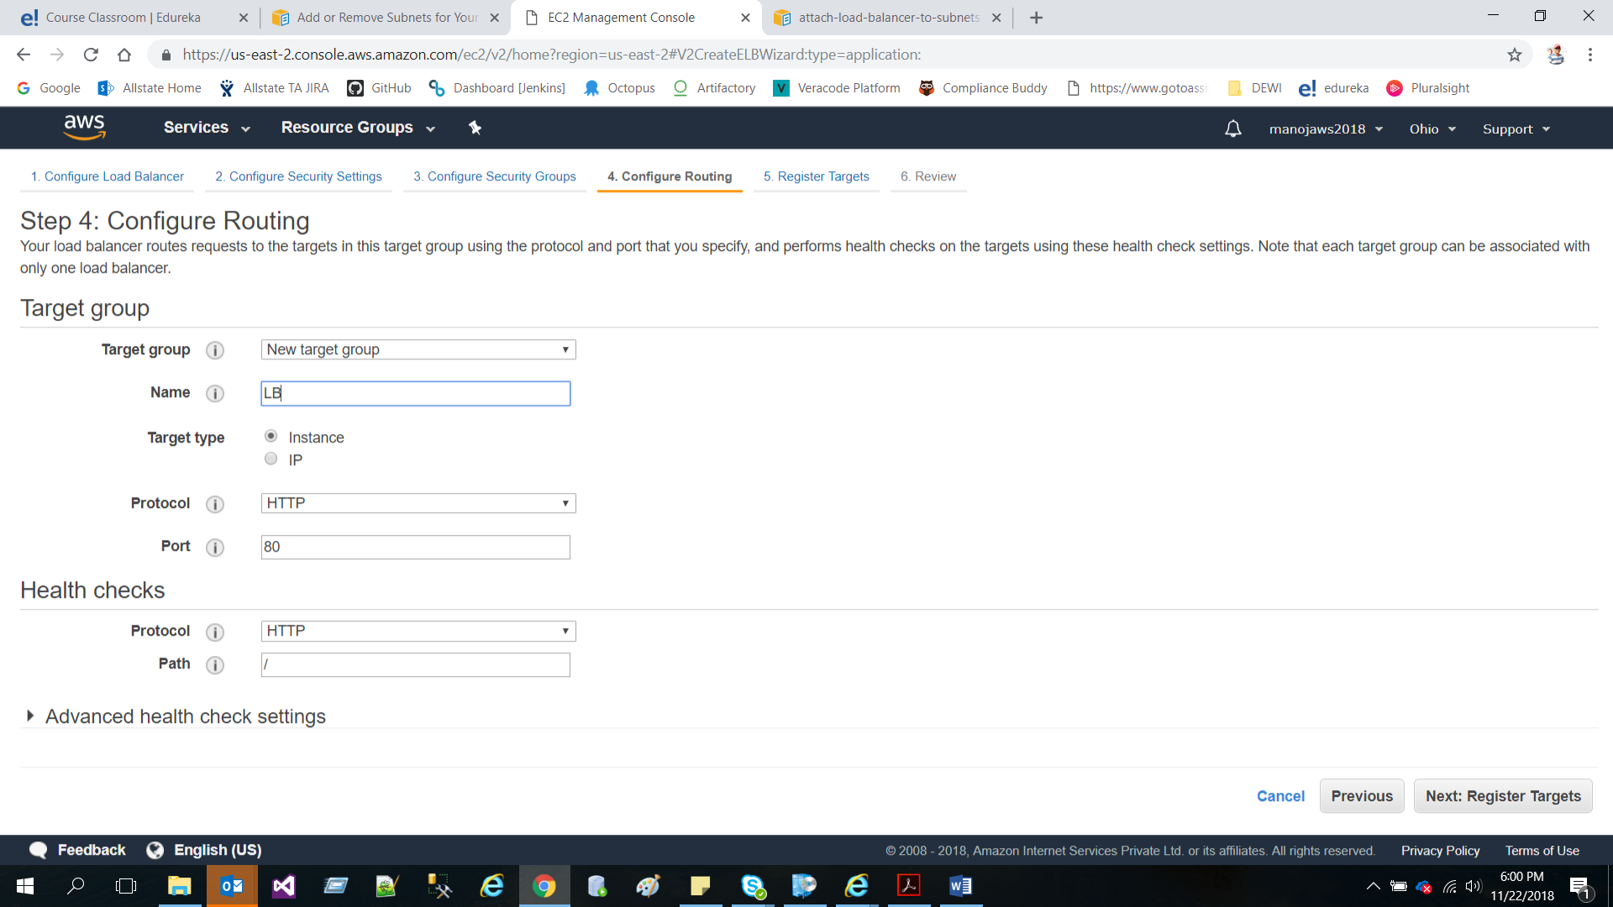

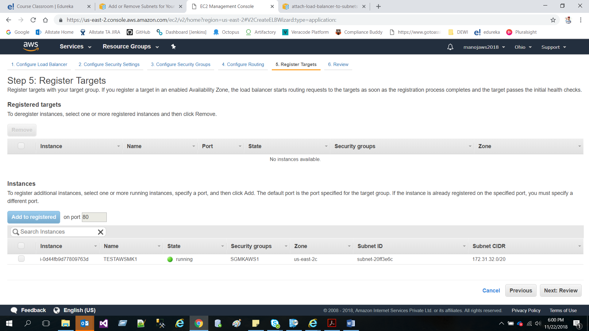

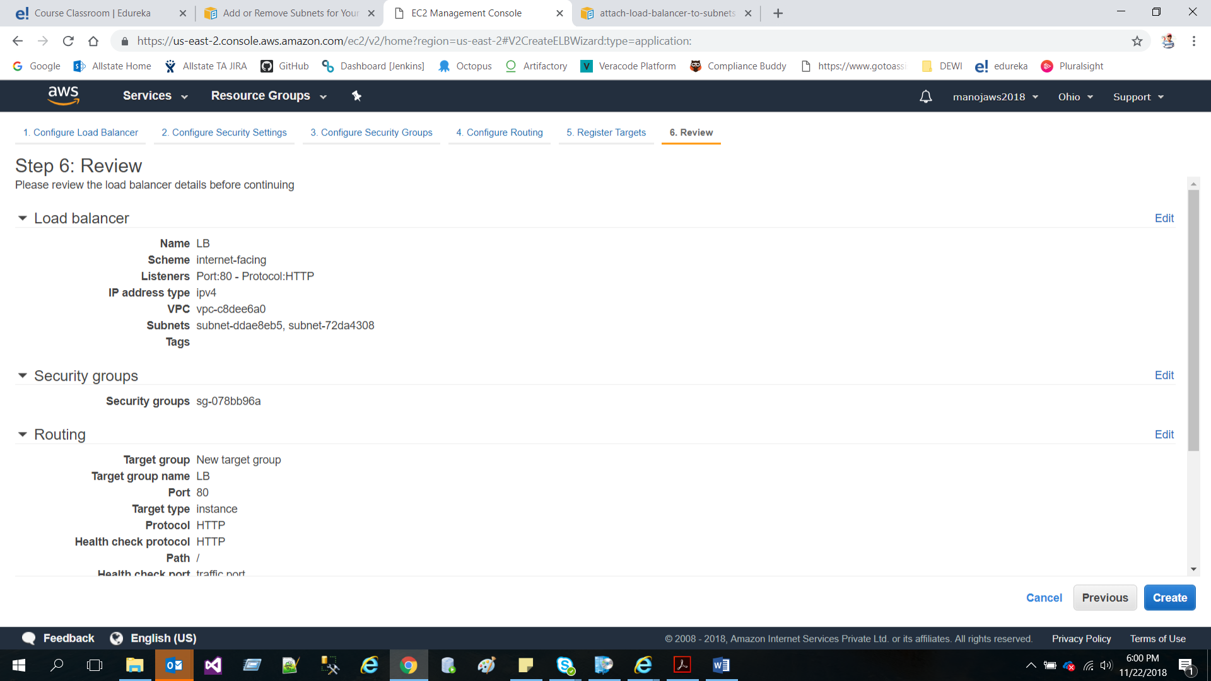

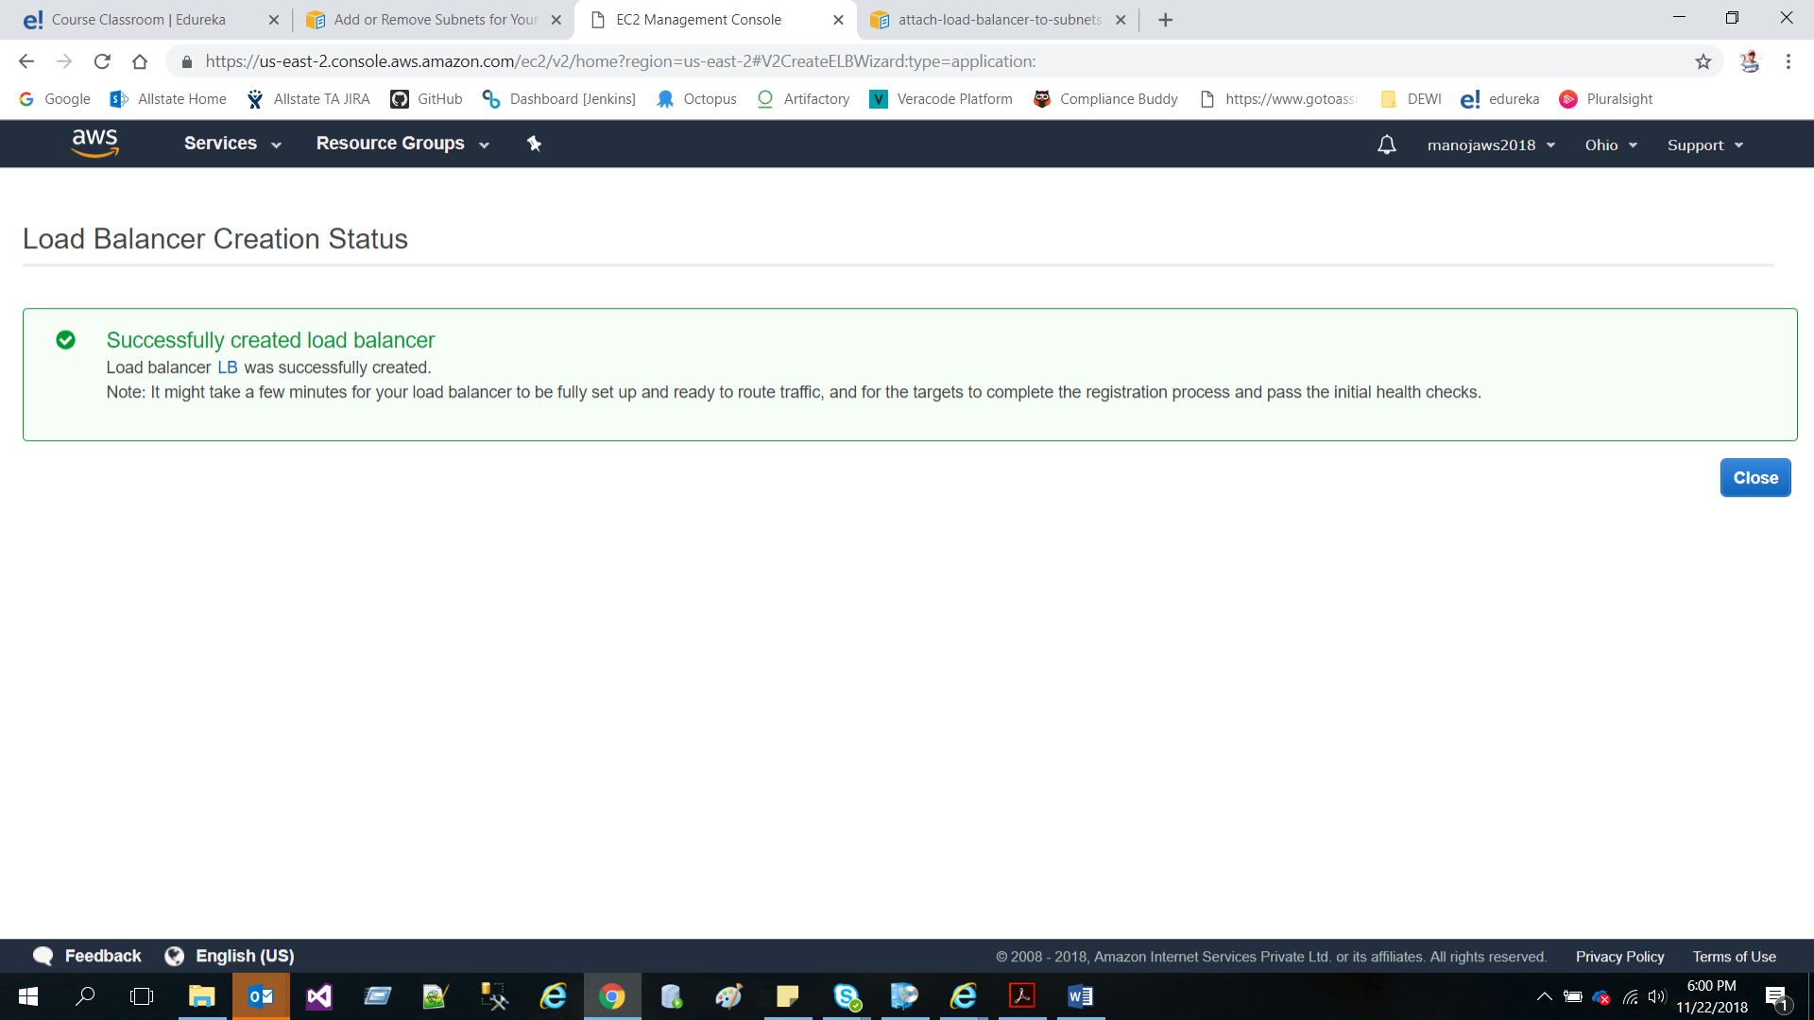

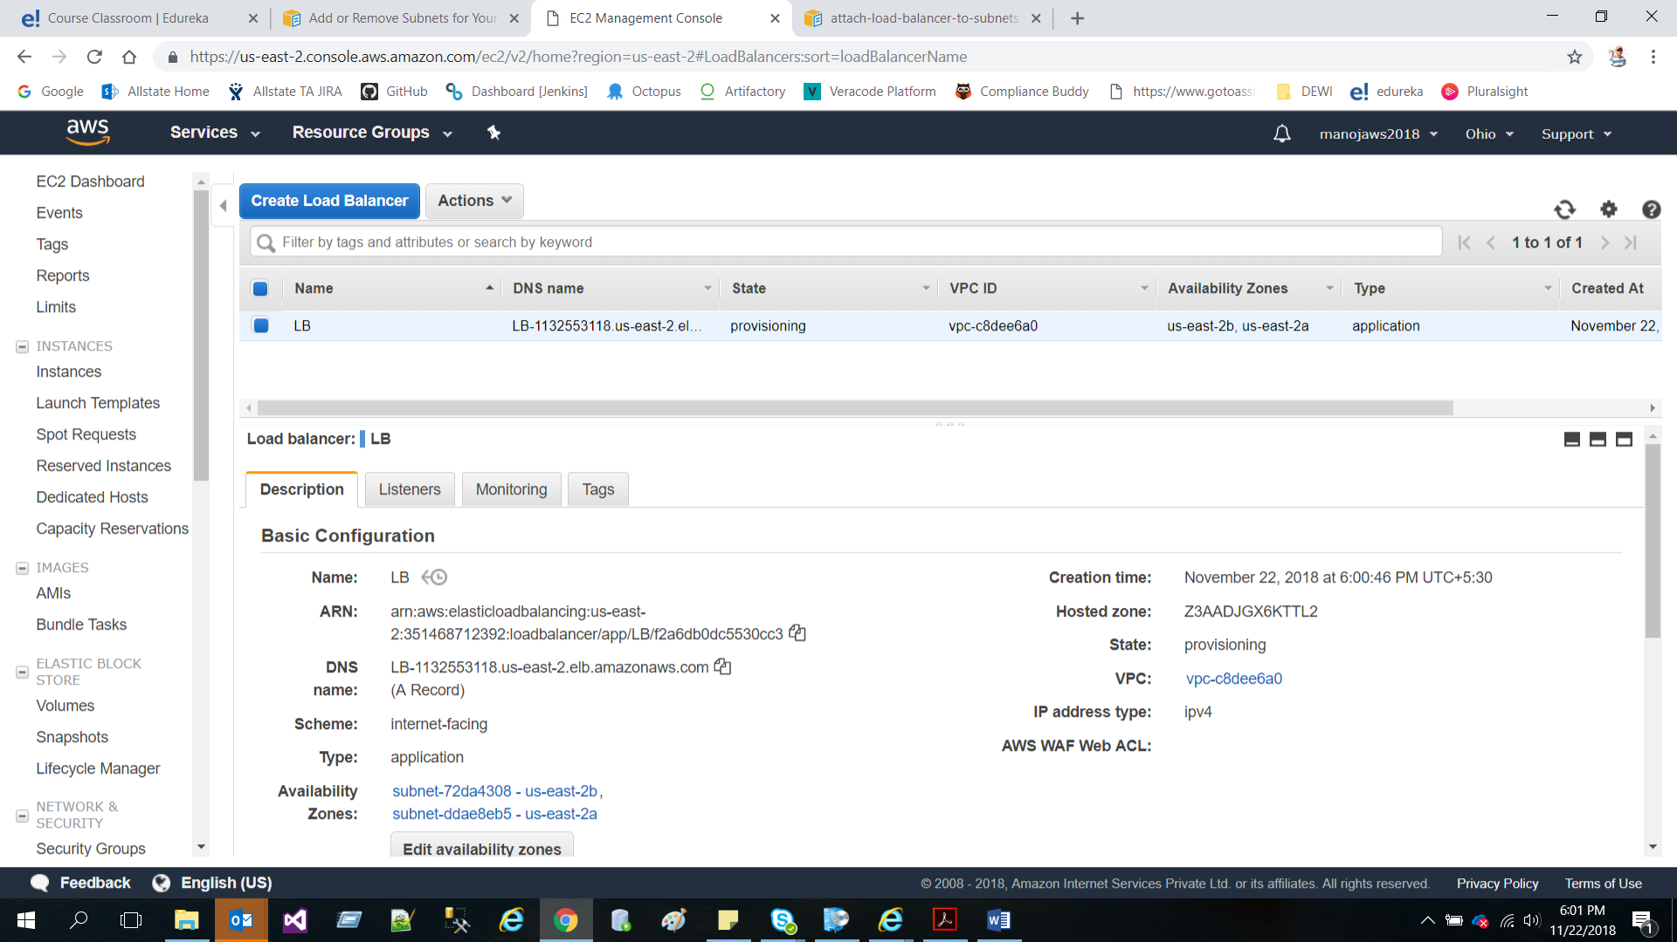

* Create two private subnets for each Availability Zone

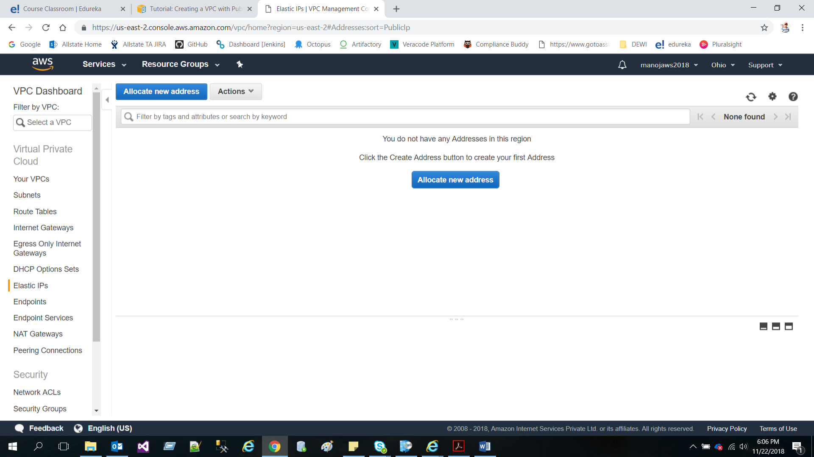

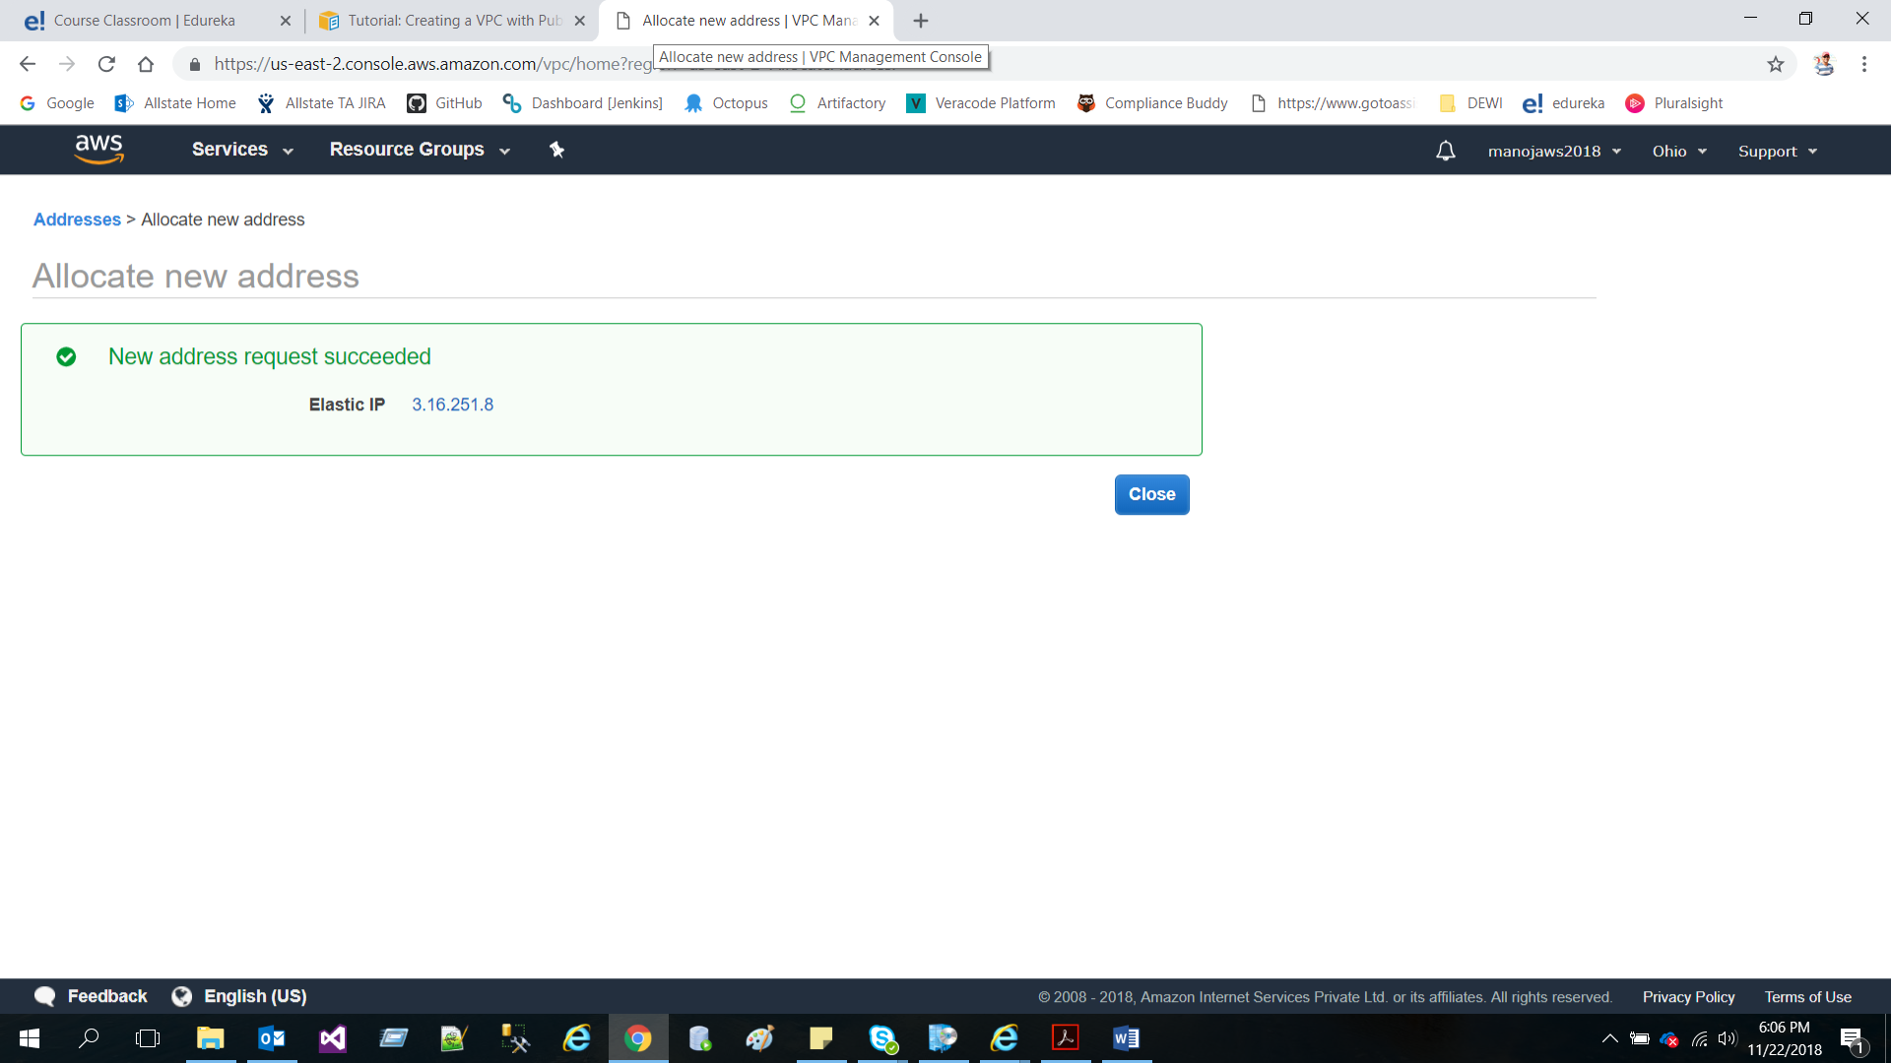

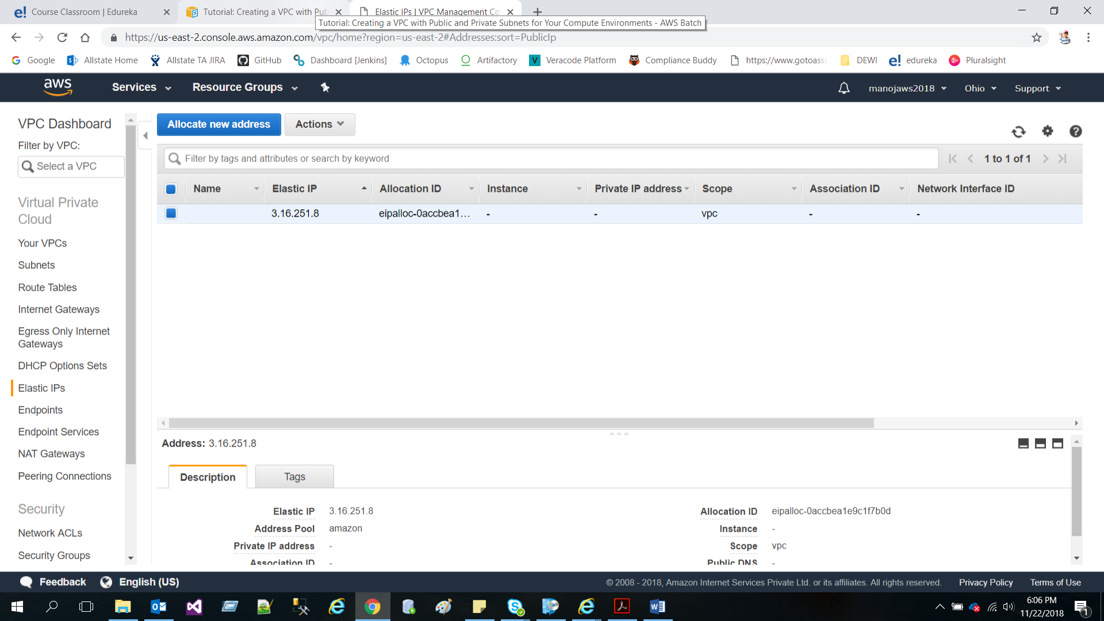

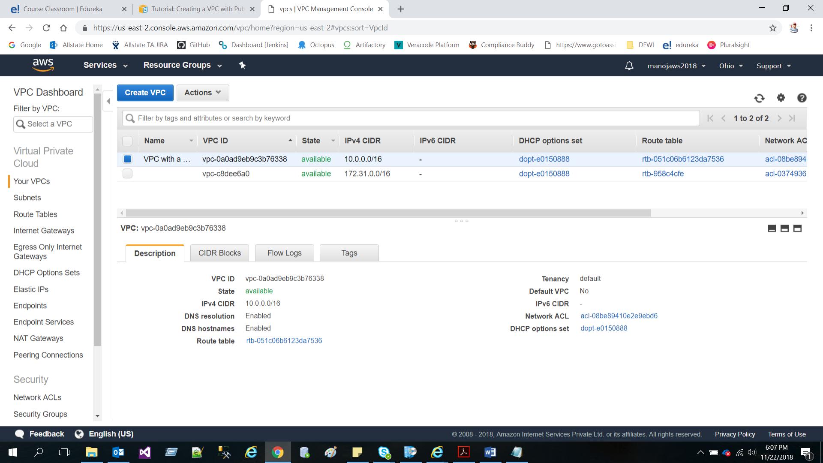

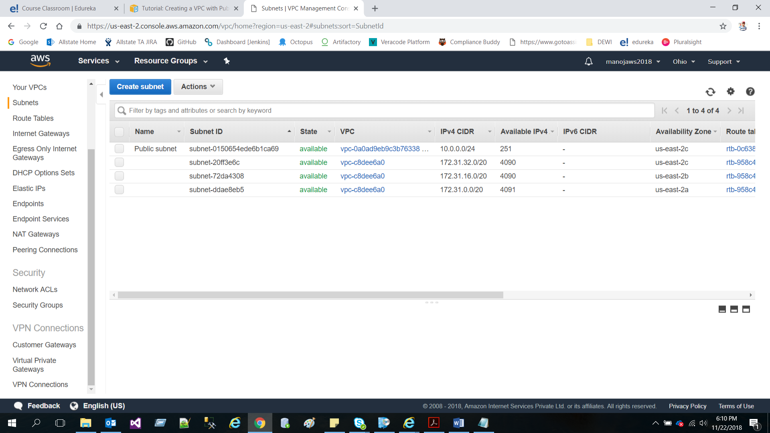

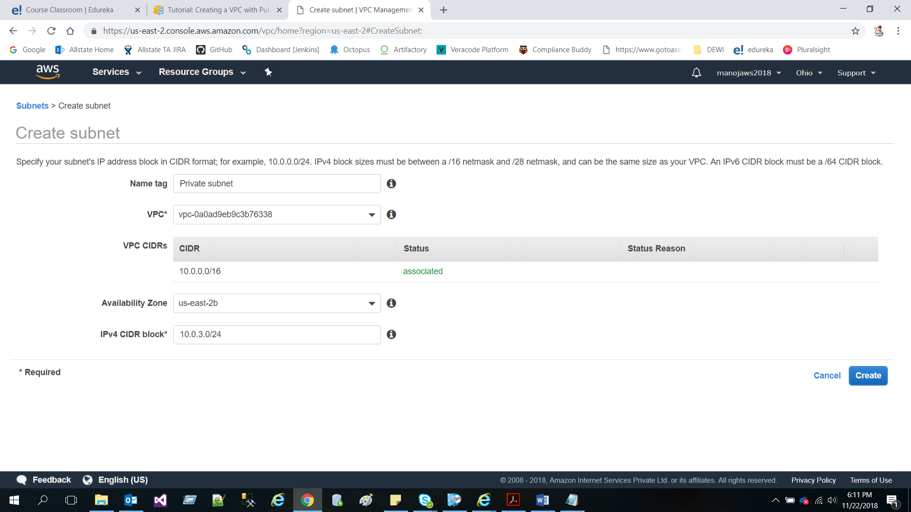

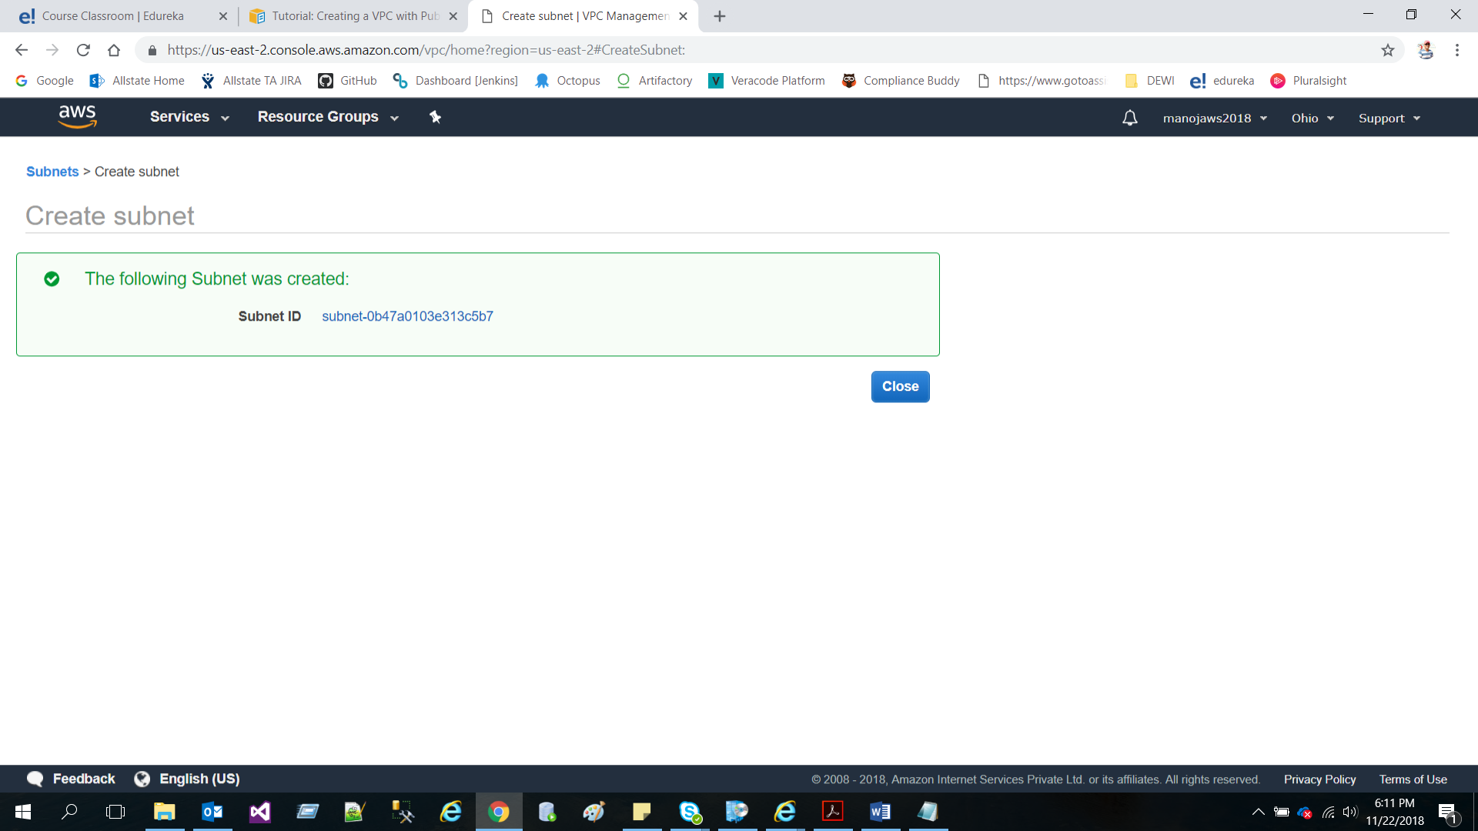

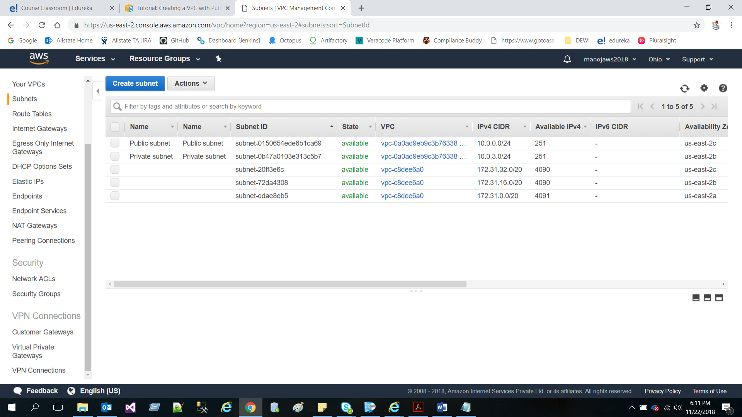

Step 2: Create an Application Server within your VPC

* Create a Security Group with http rule to access web application for your Amazon EC2 Instance

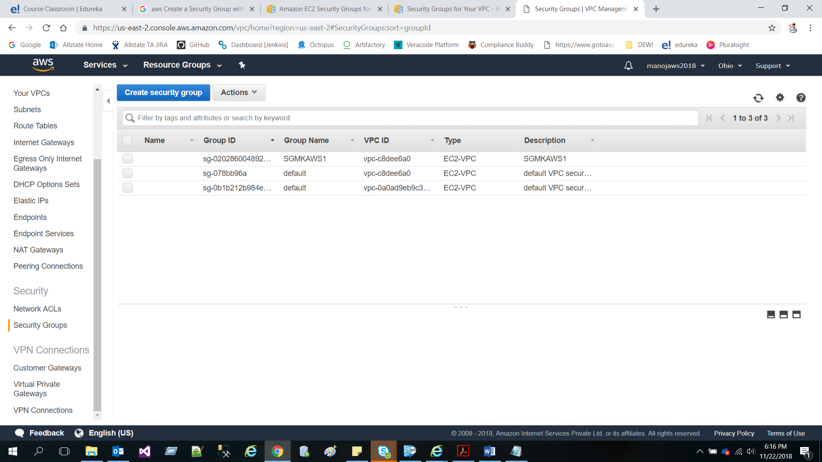

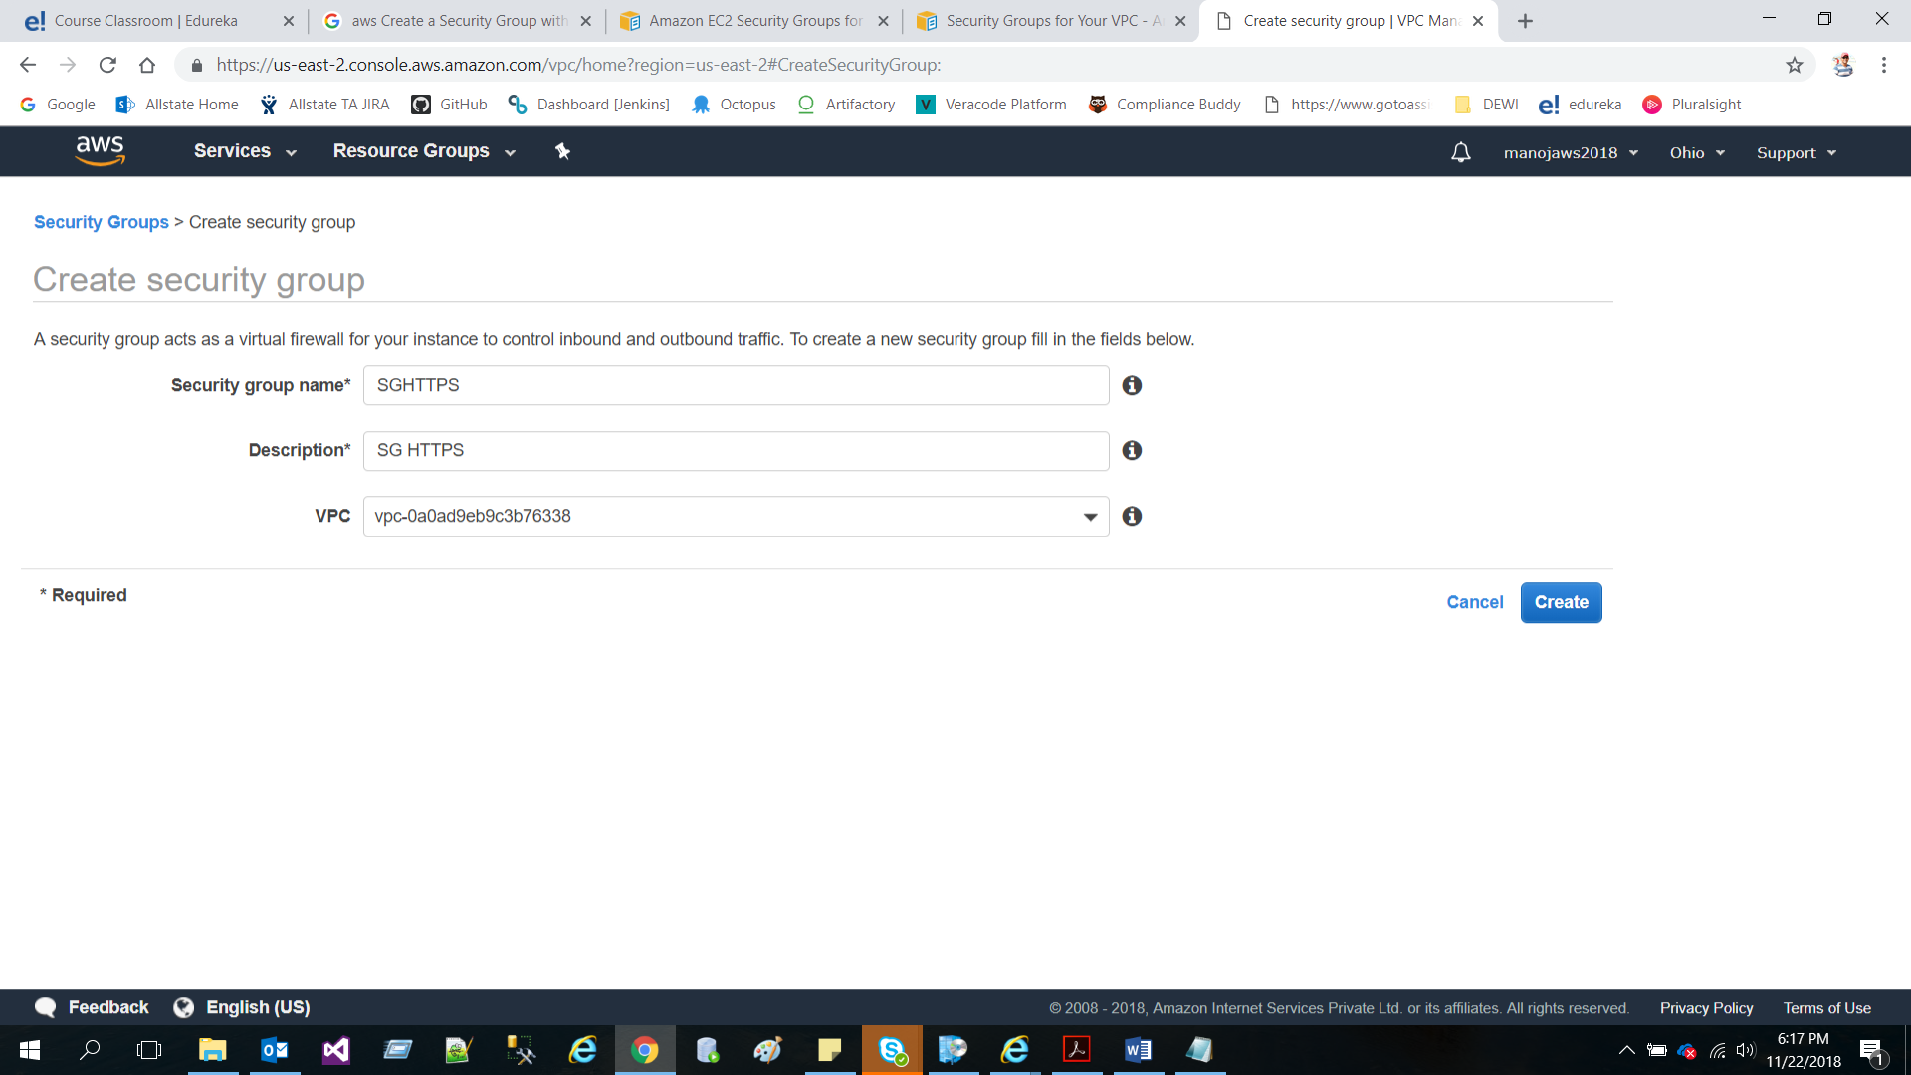

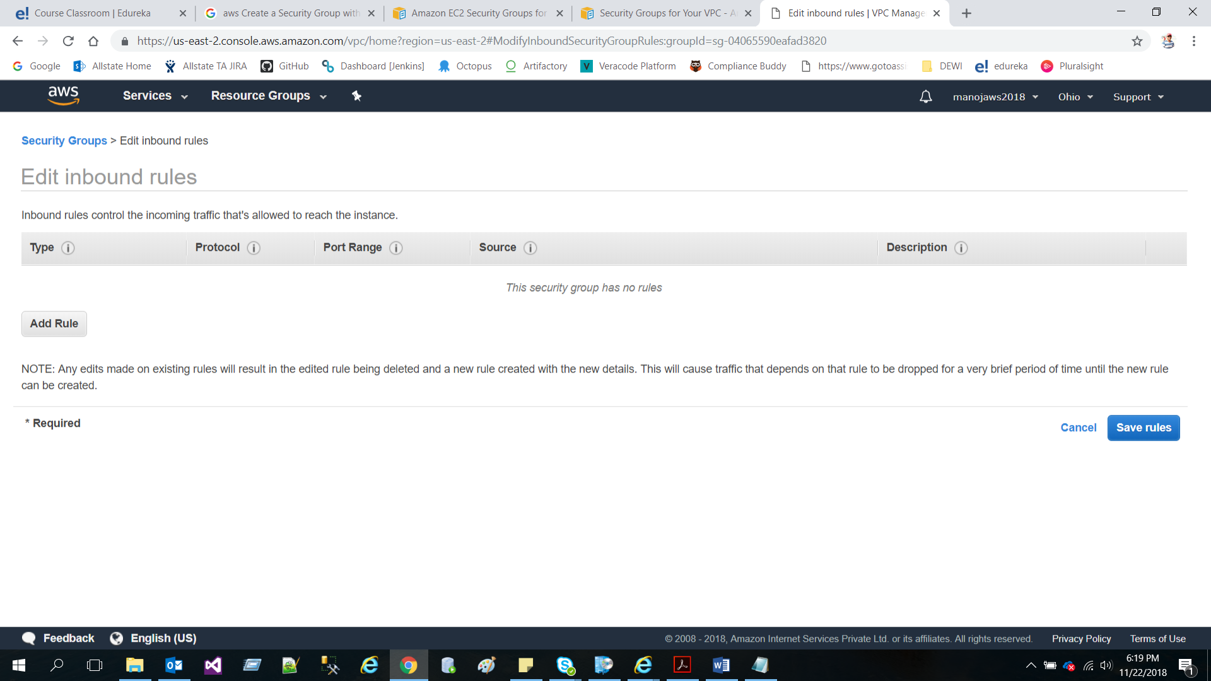

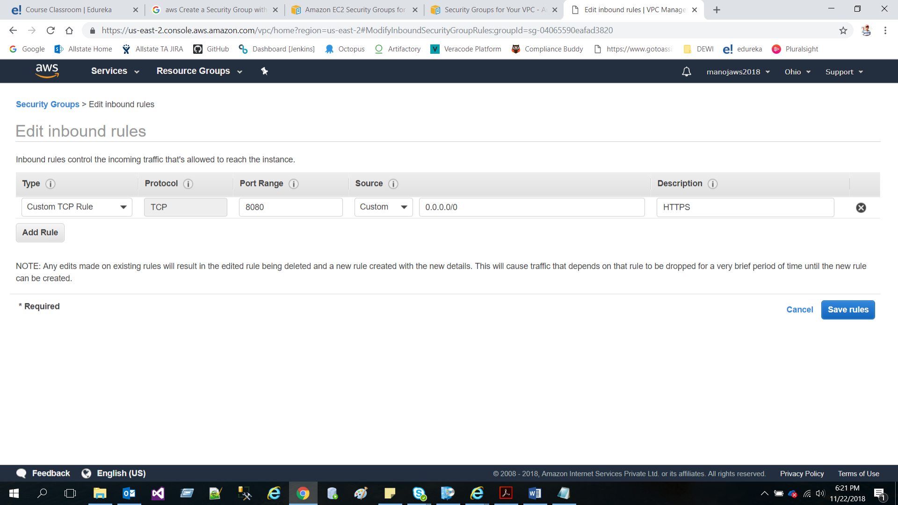

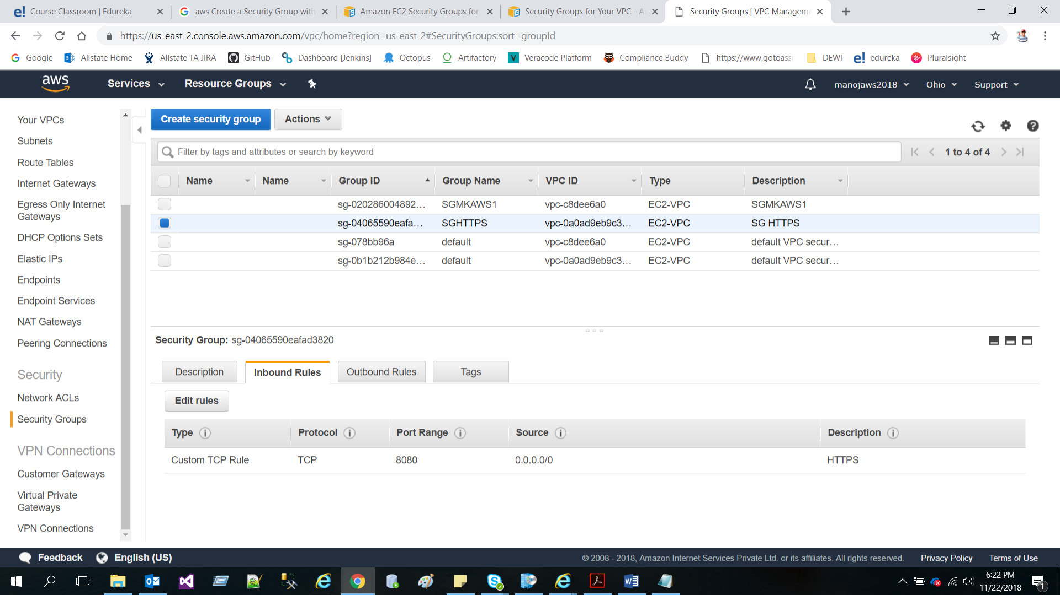

* Create an IAM Role to provide full access to EC2 Instance

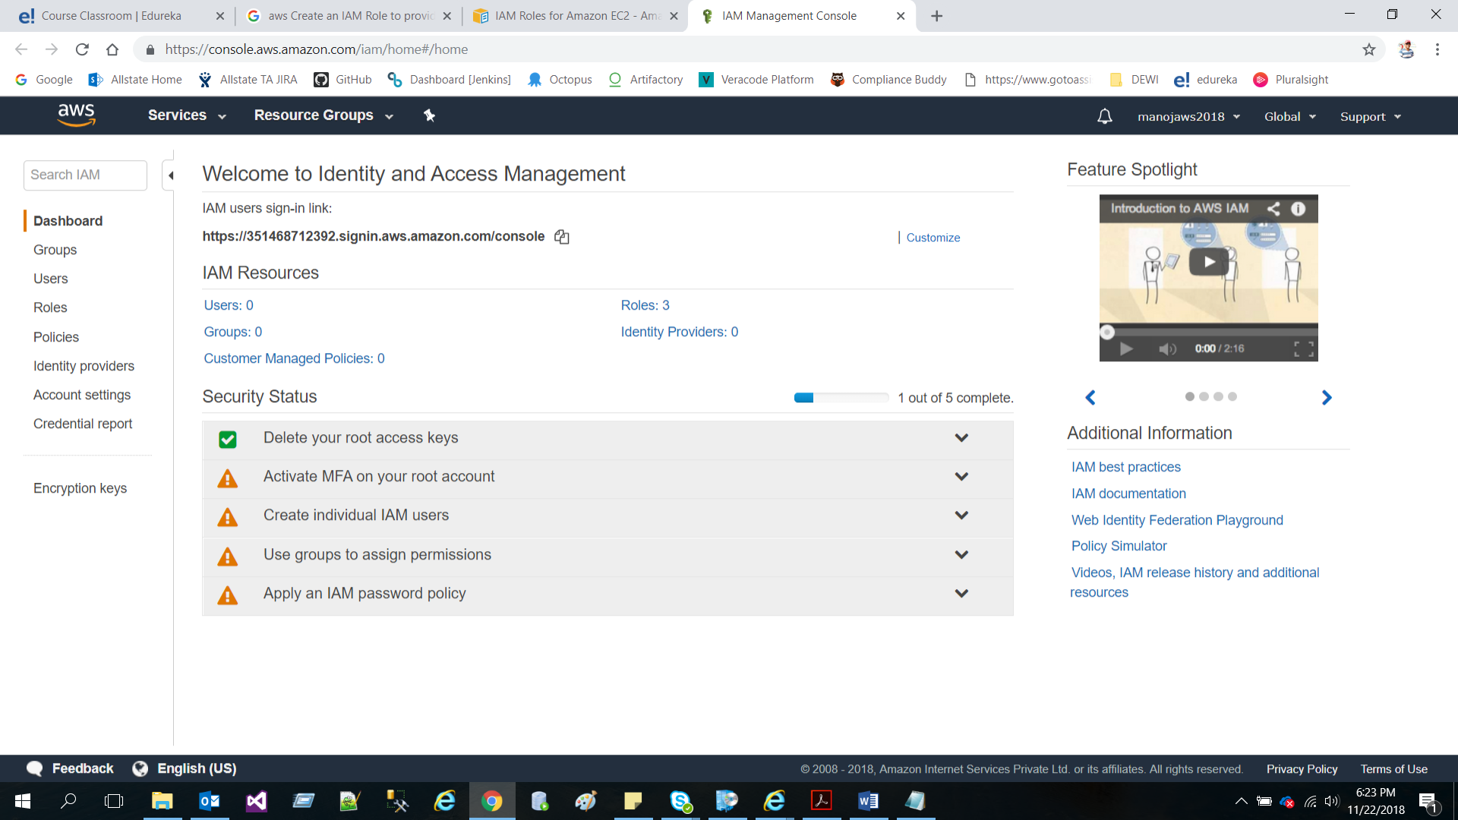

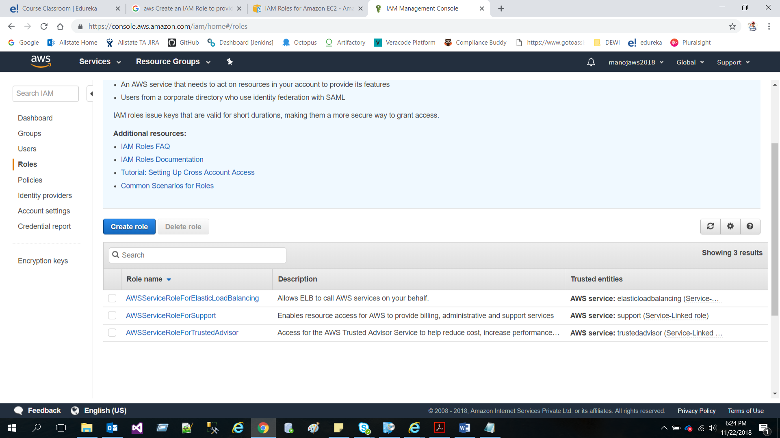

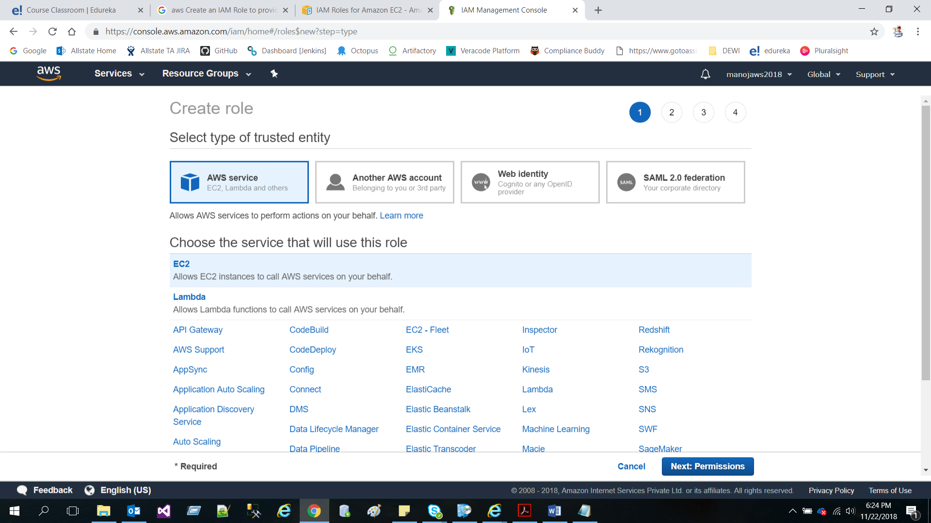

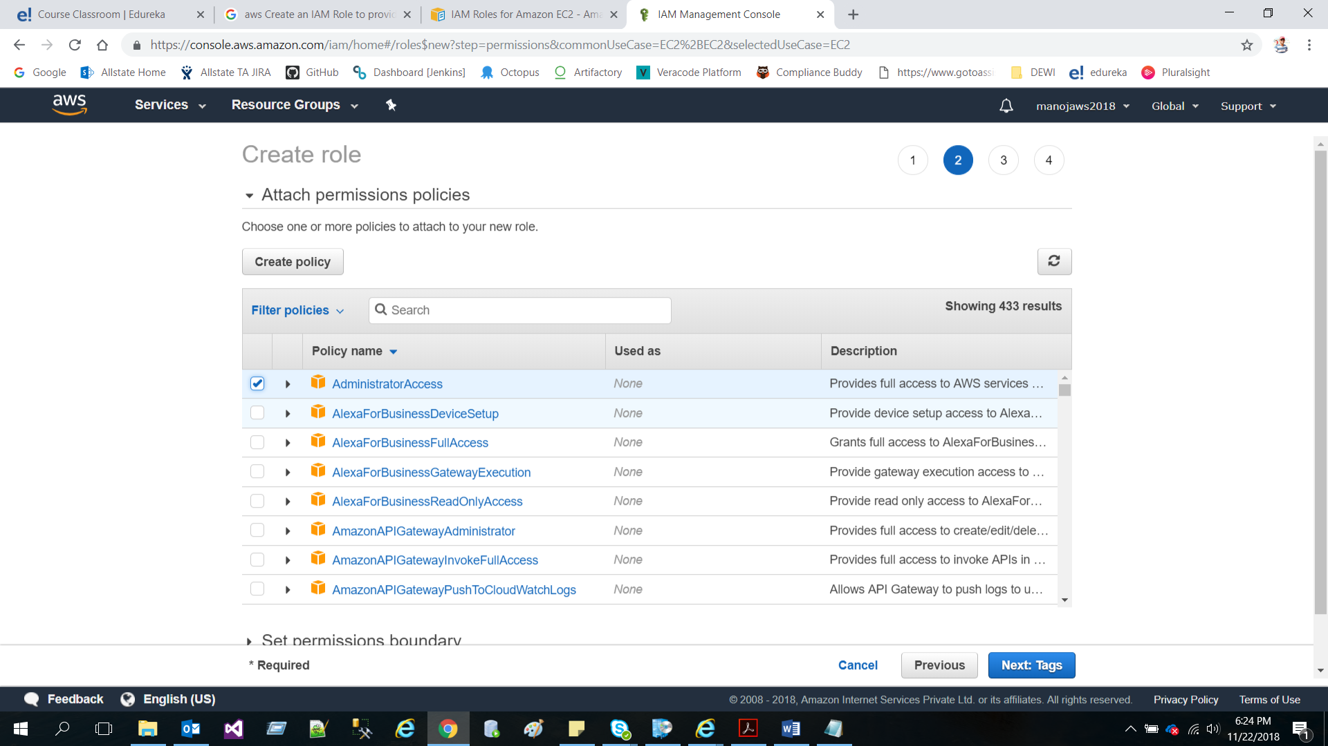

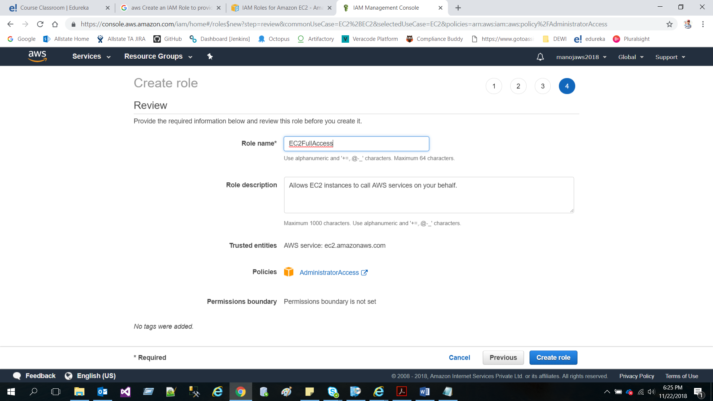

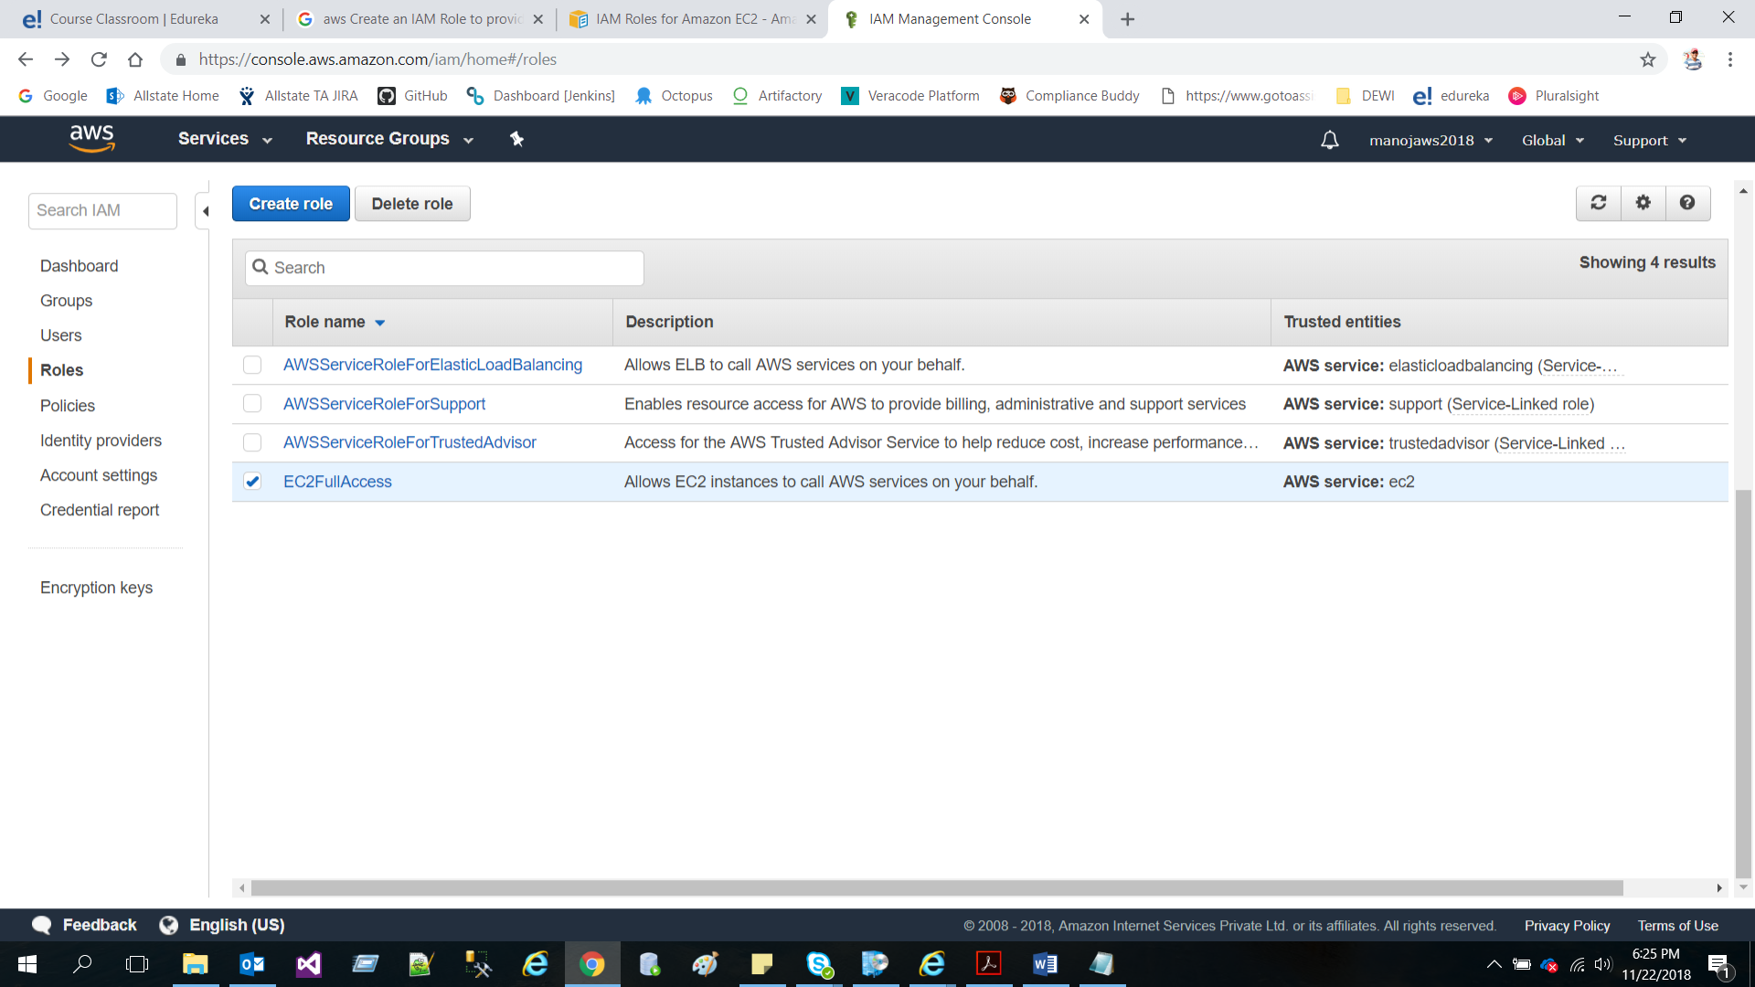

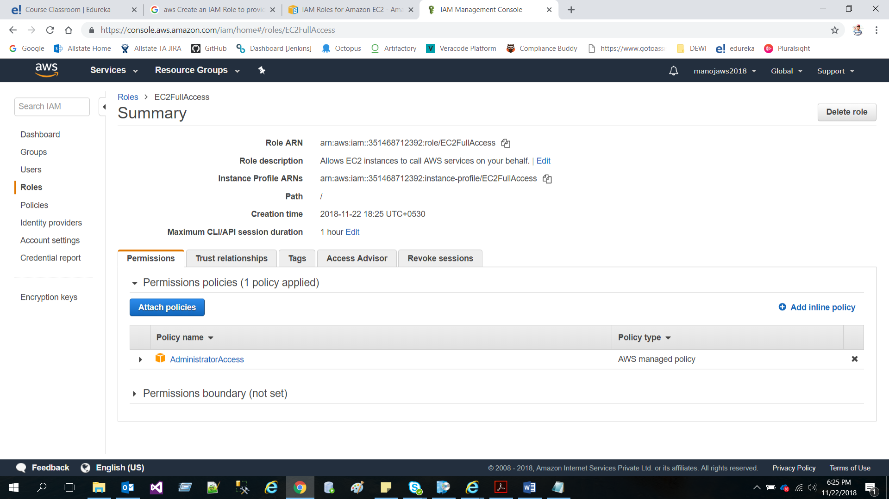

* Launch an EC2 free tier Amazon Linux Instance

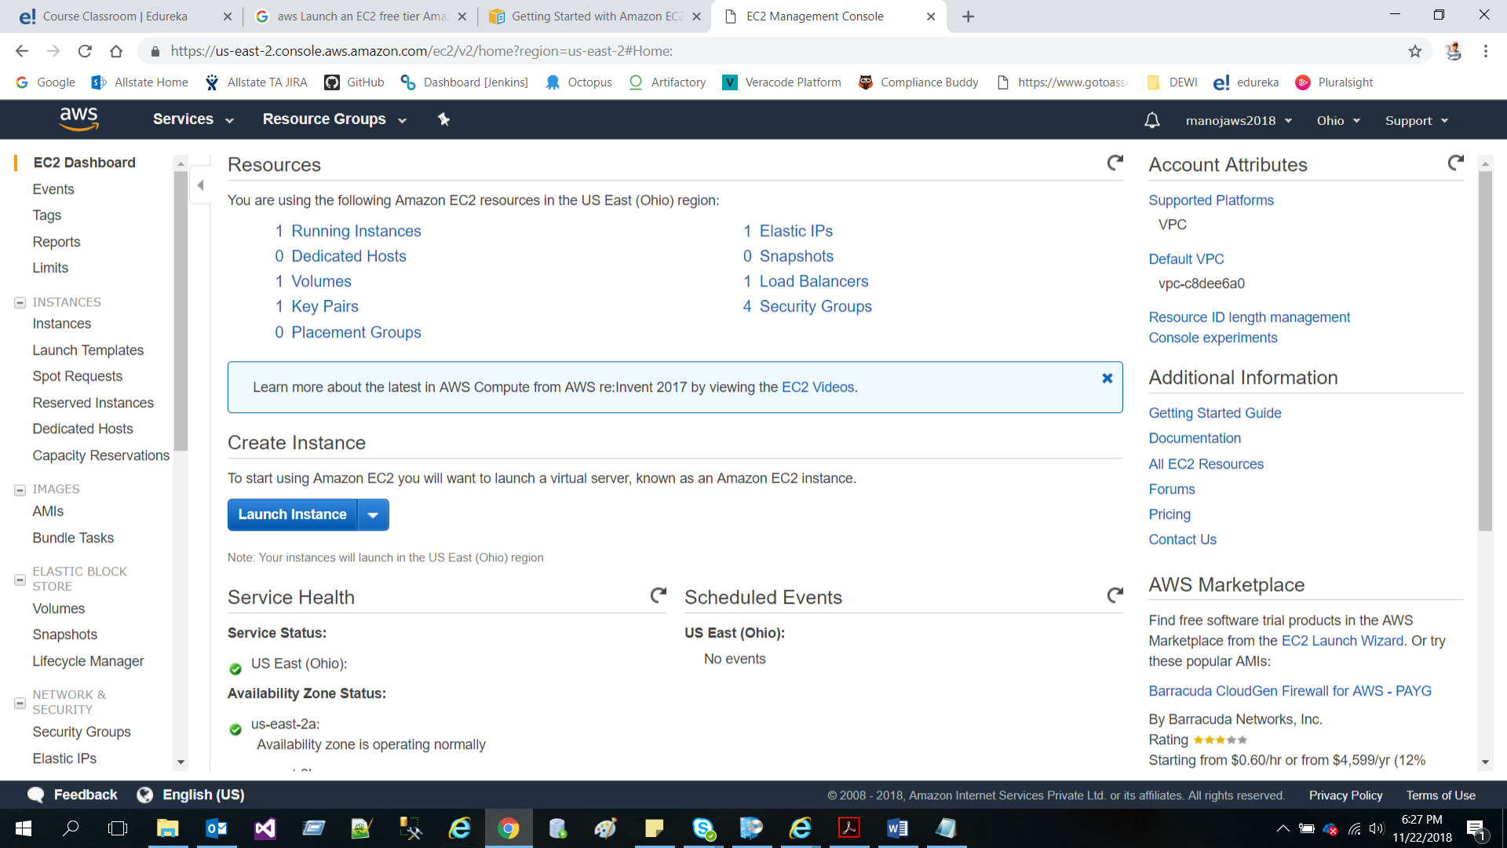

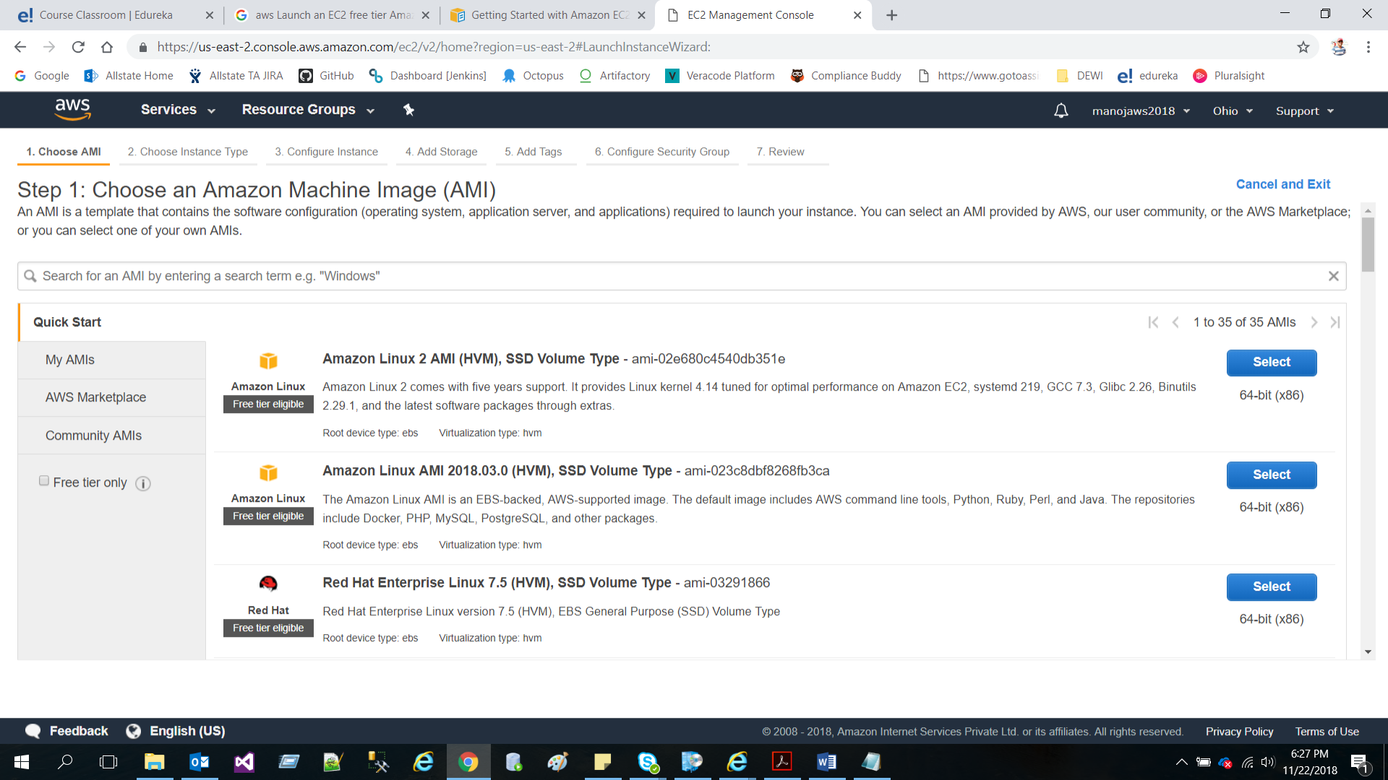

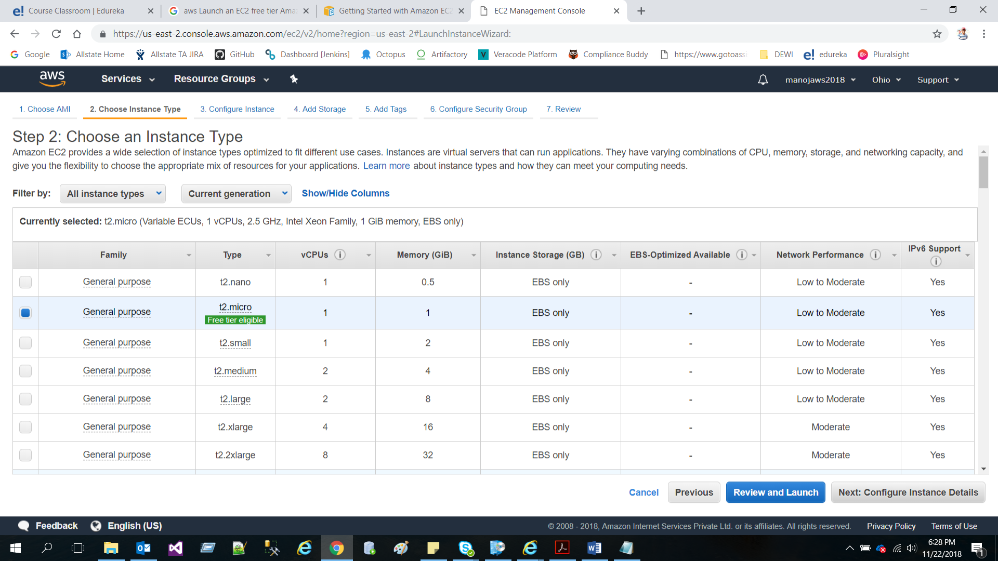

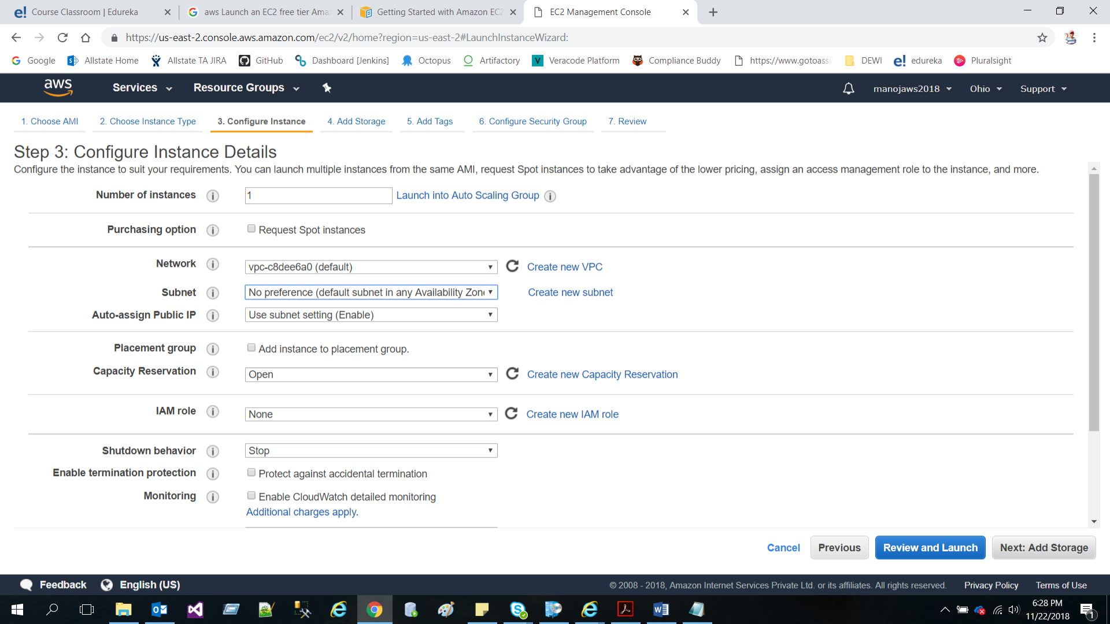

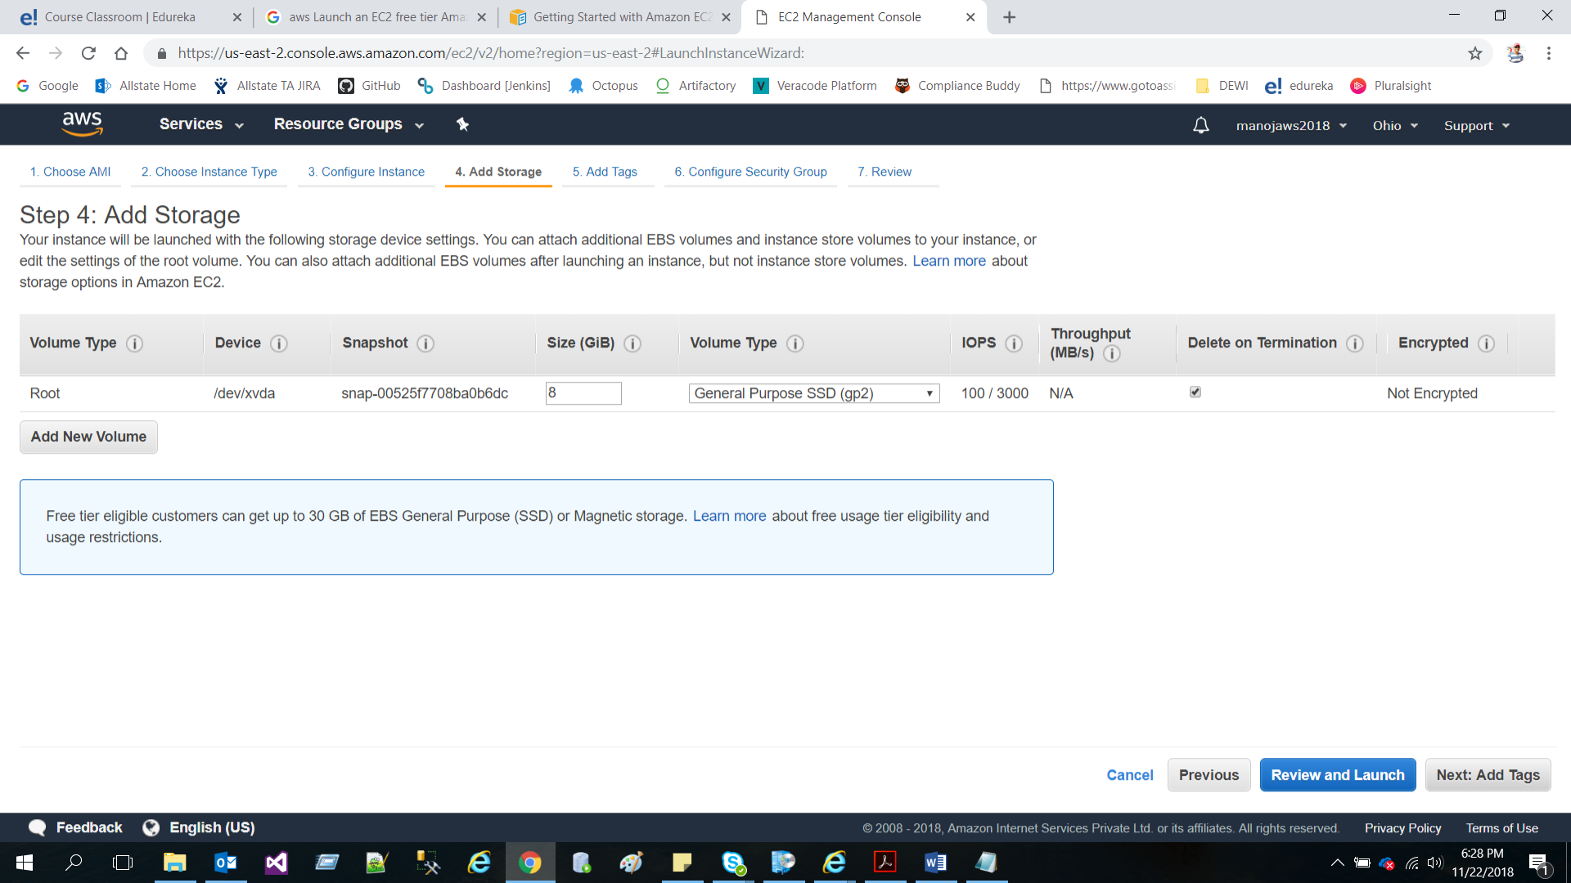

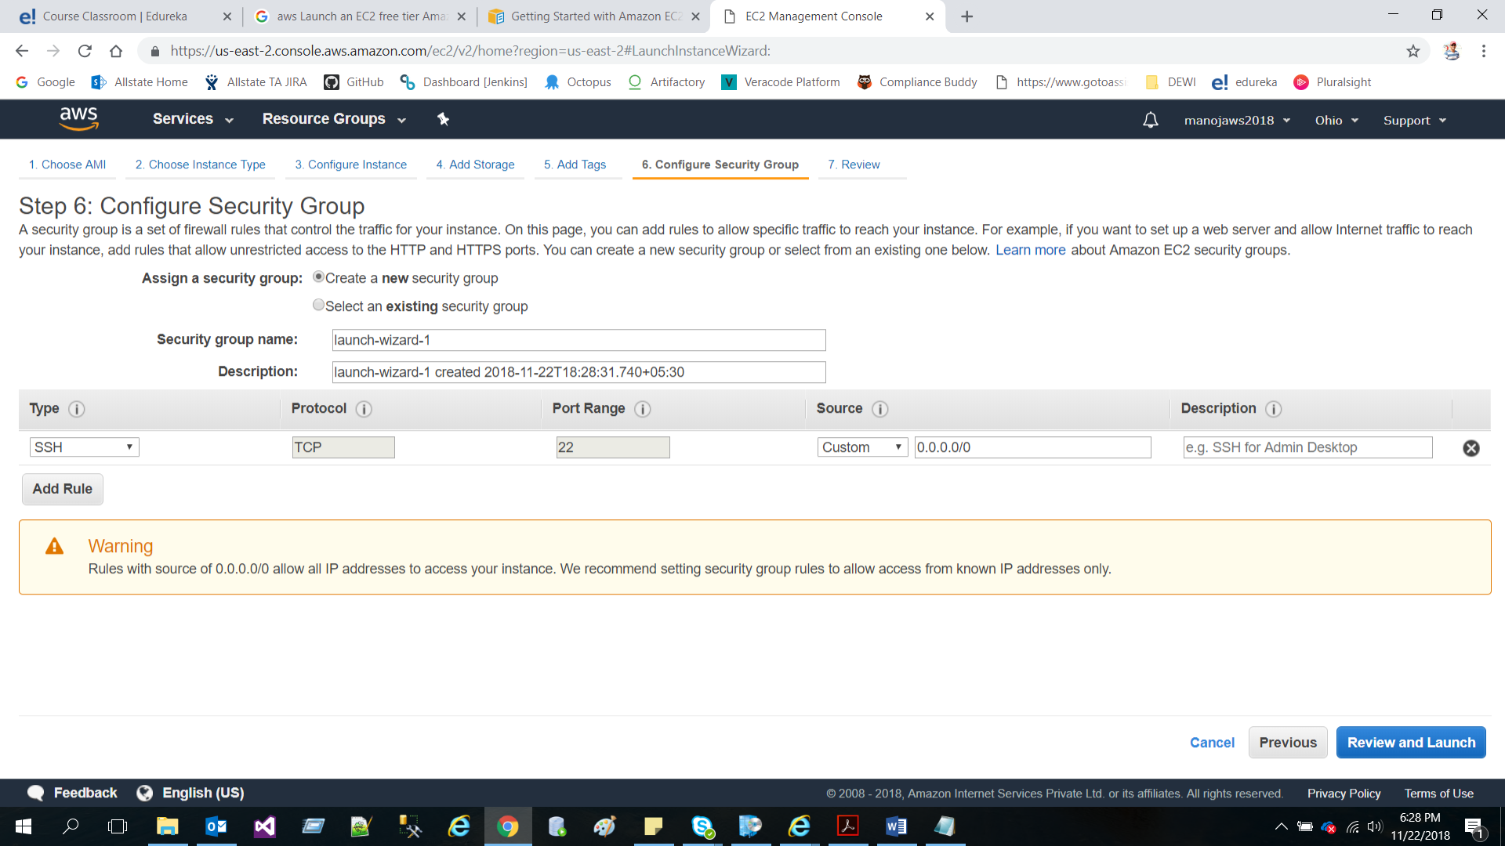

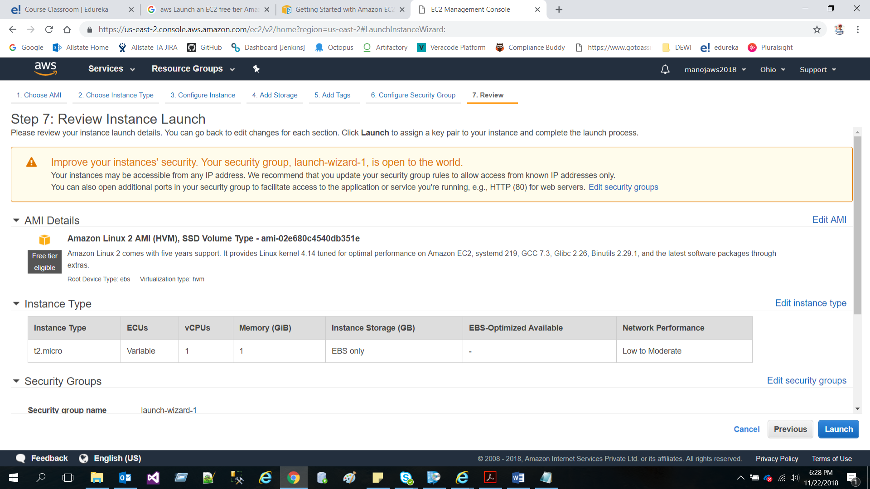

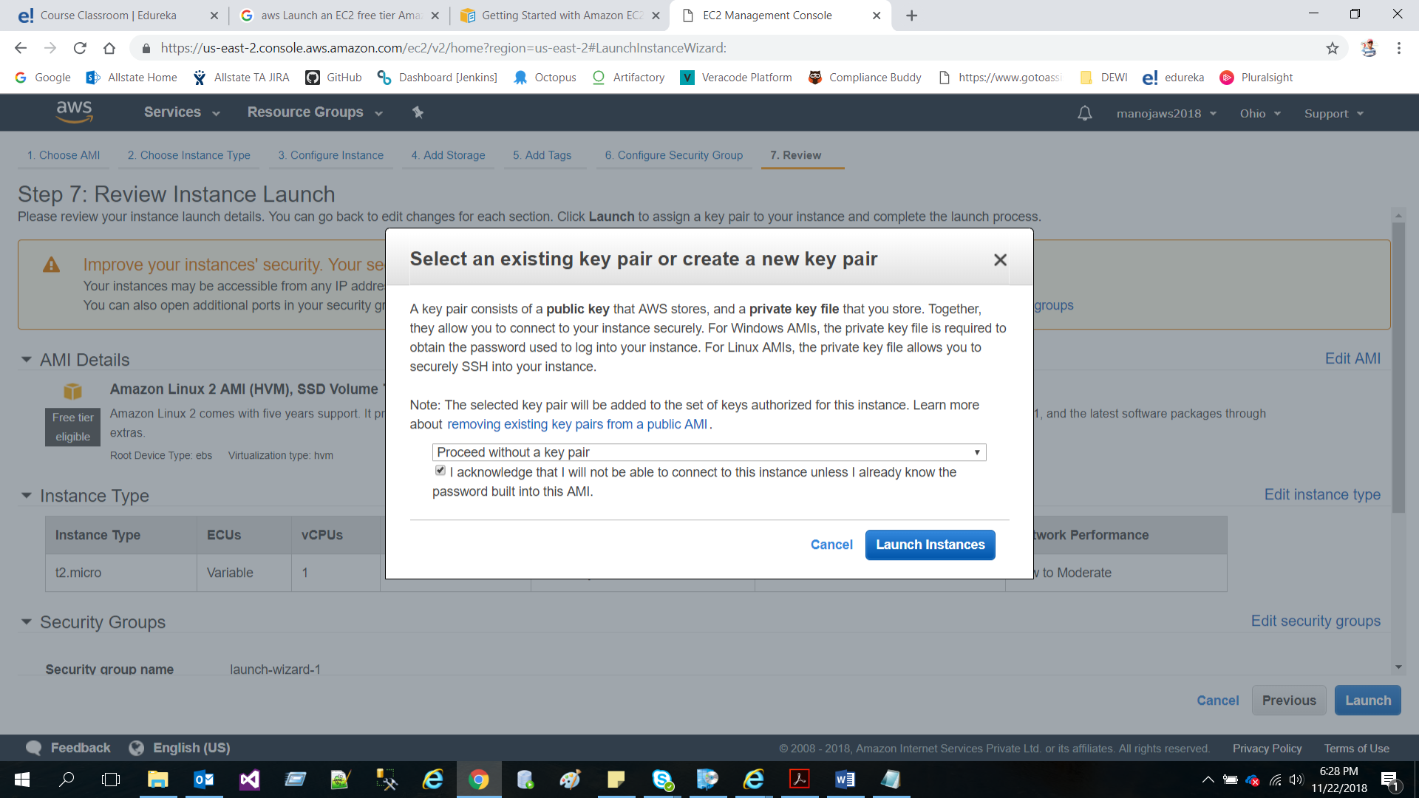

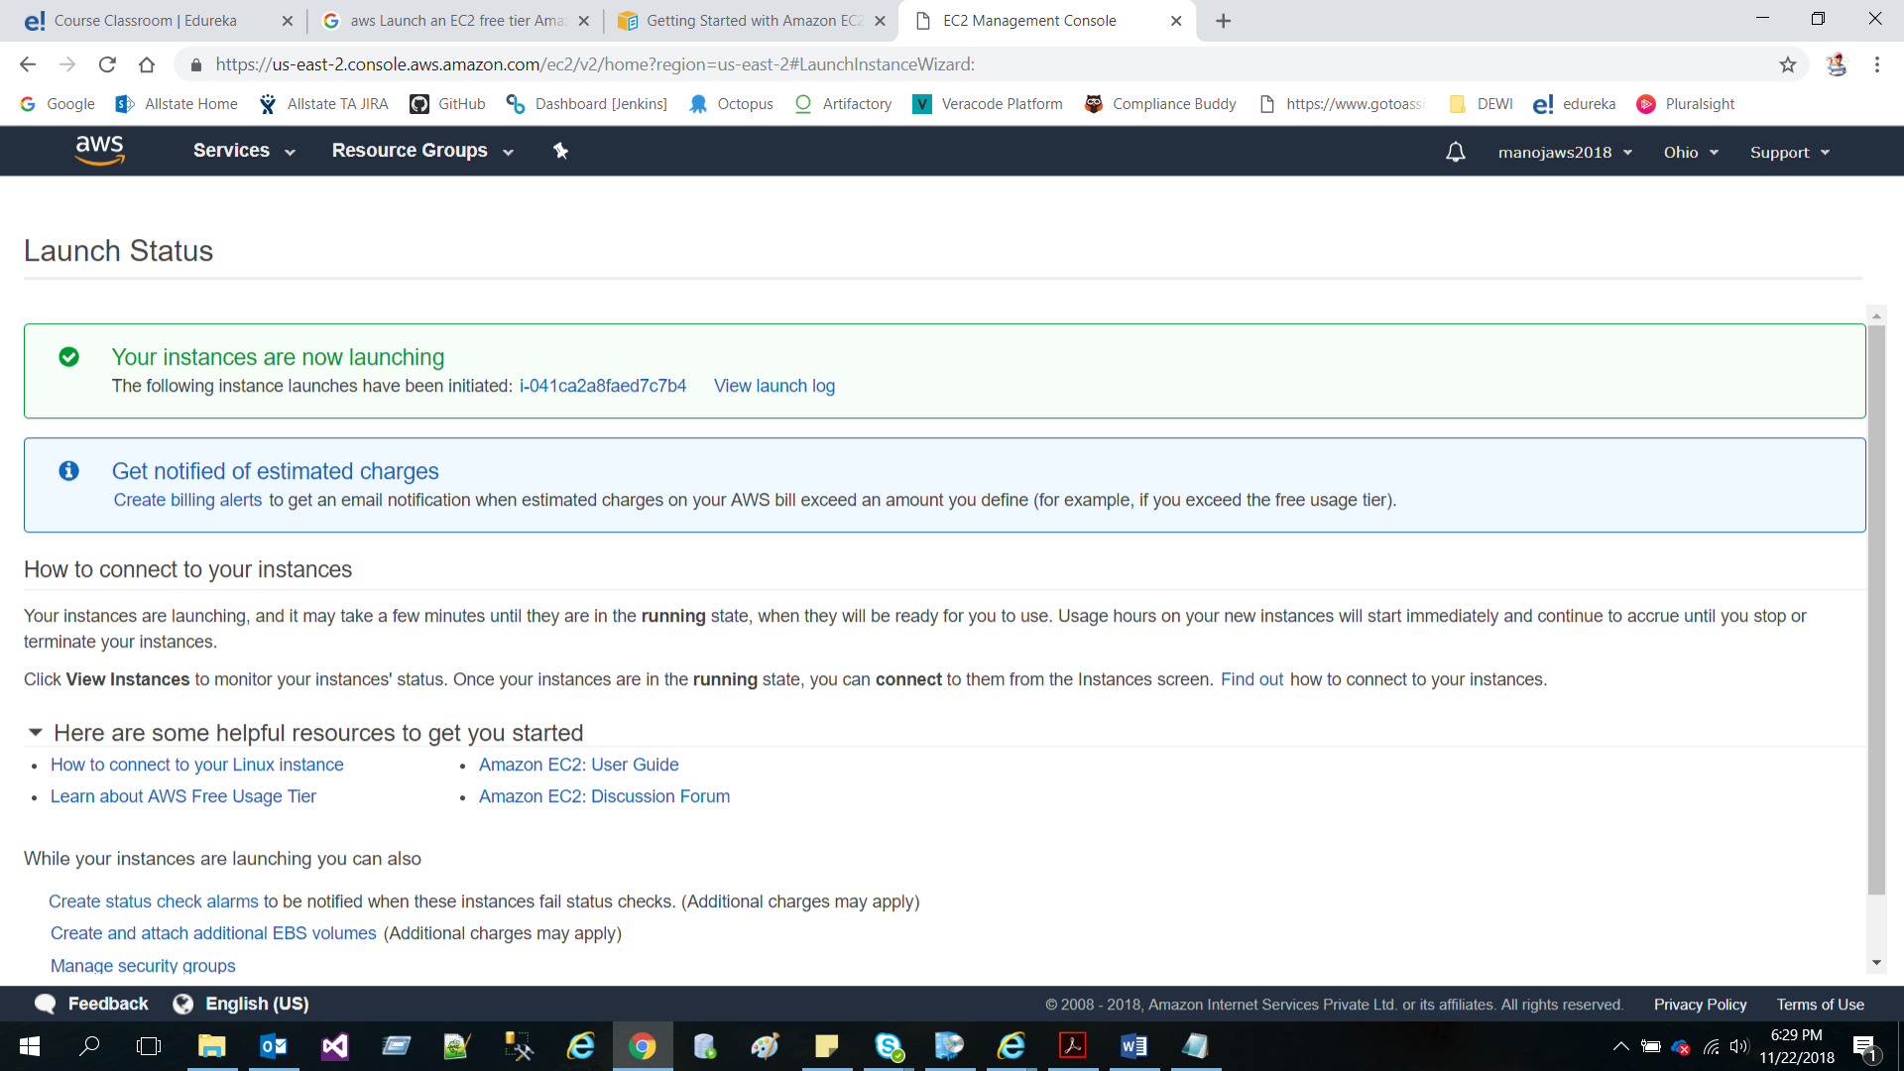

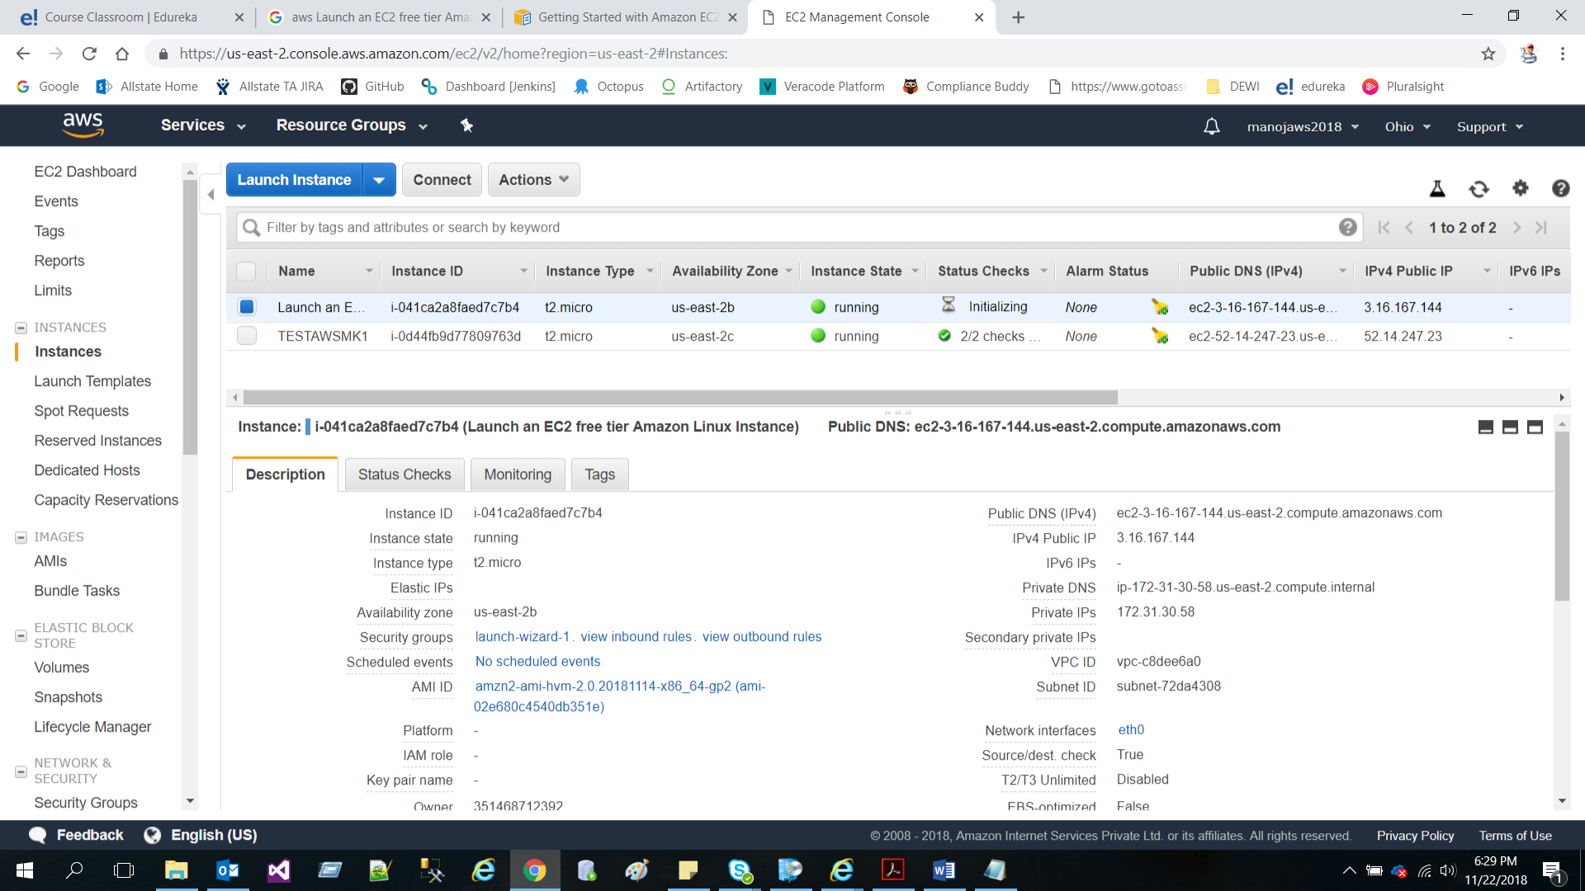

Step 3: Create a Database Server within your VPC

* Create a Security Group with MySQL/Aurora rule for your DB Instance

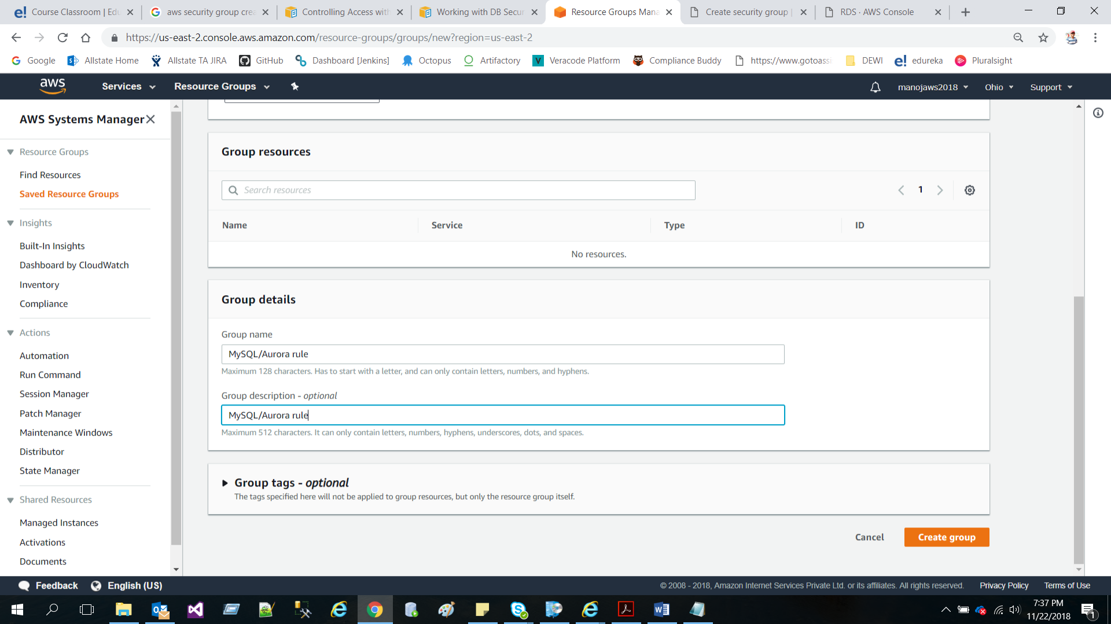

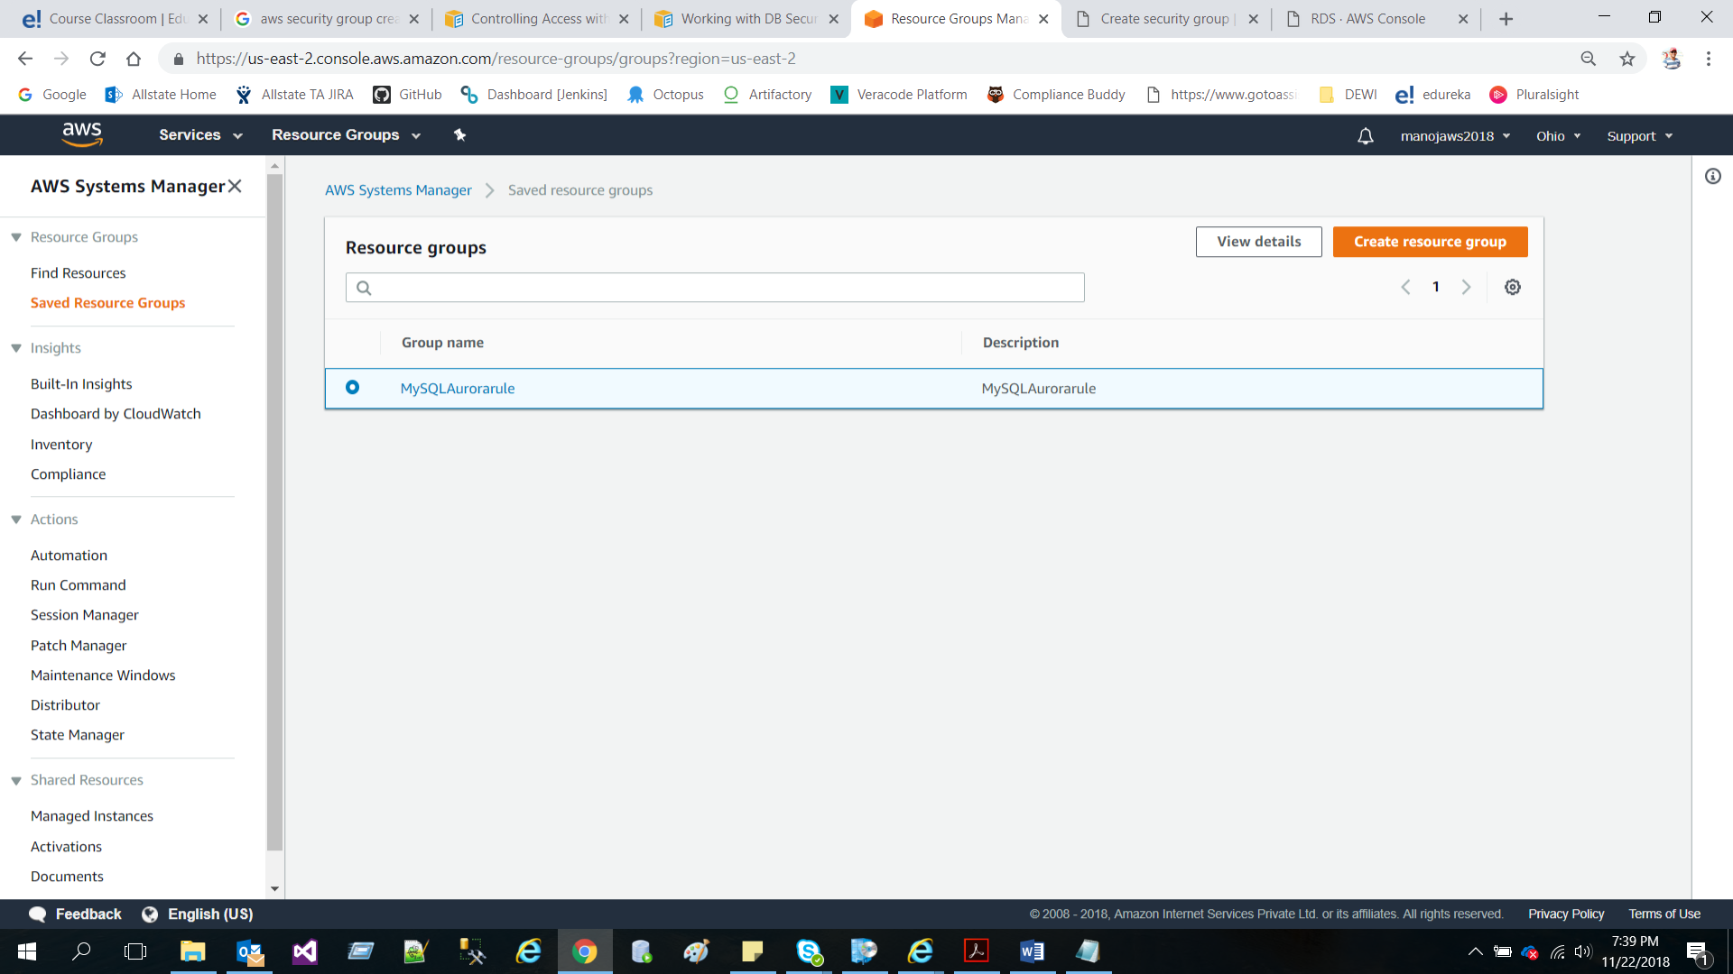

* Launch a MySQL RDS DB Instance

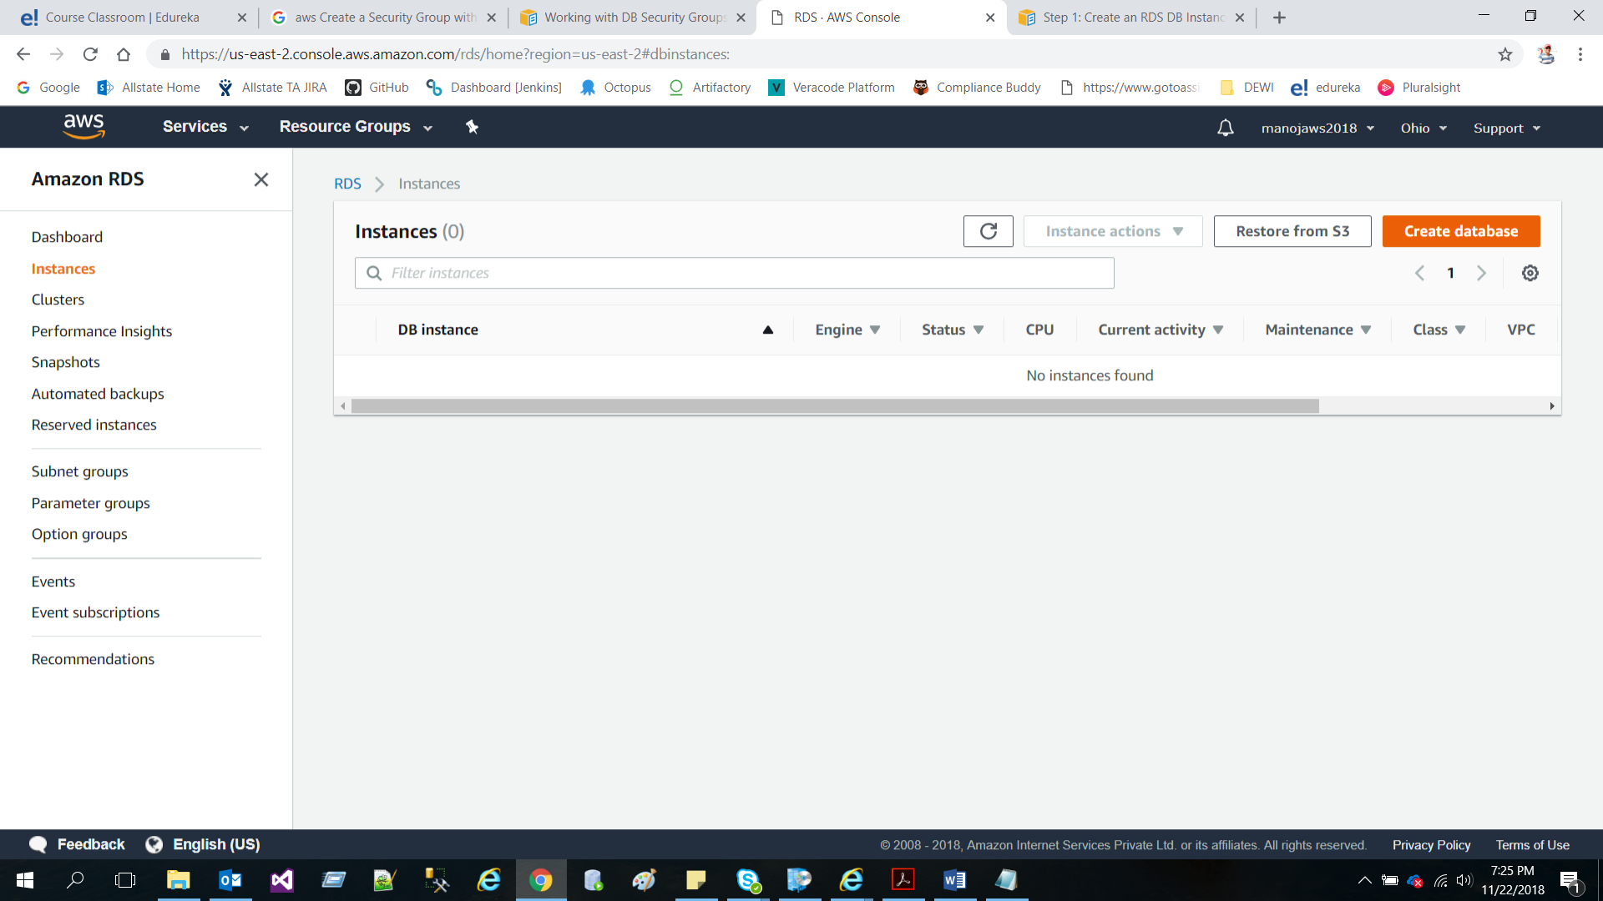

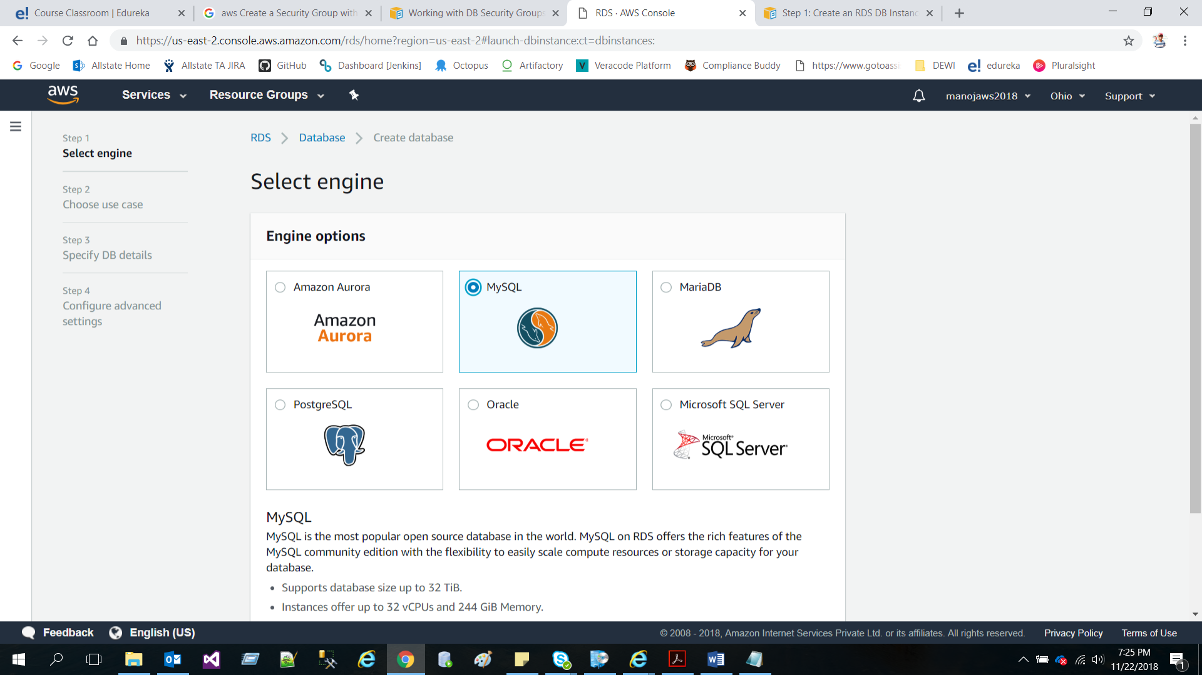

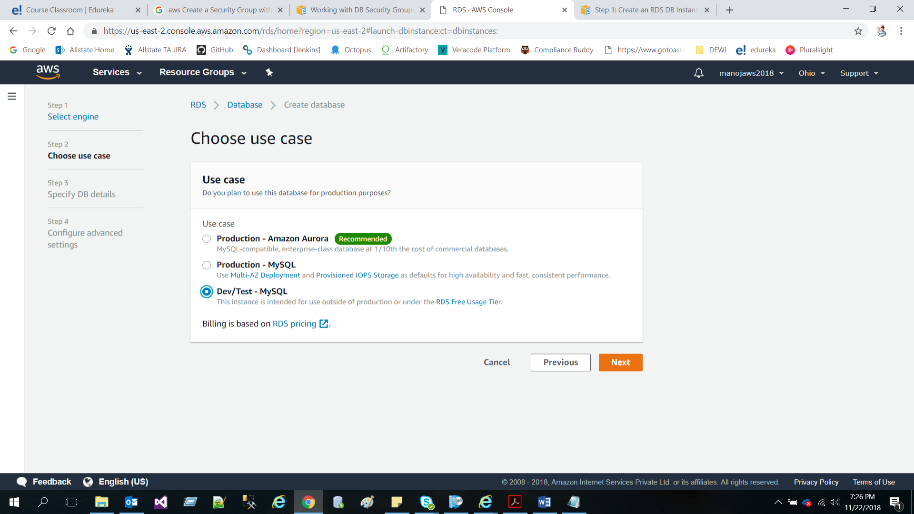

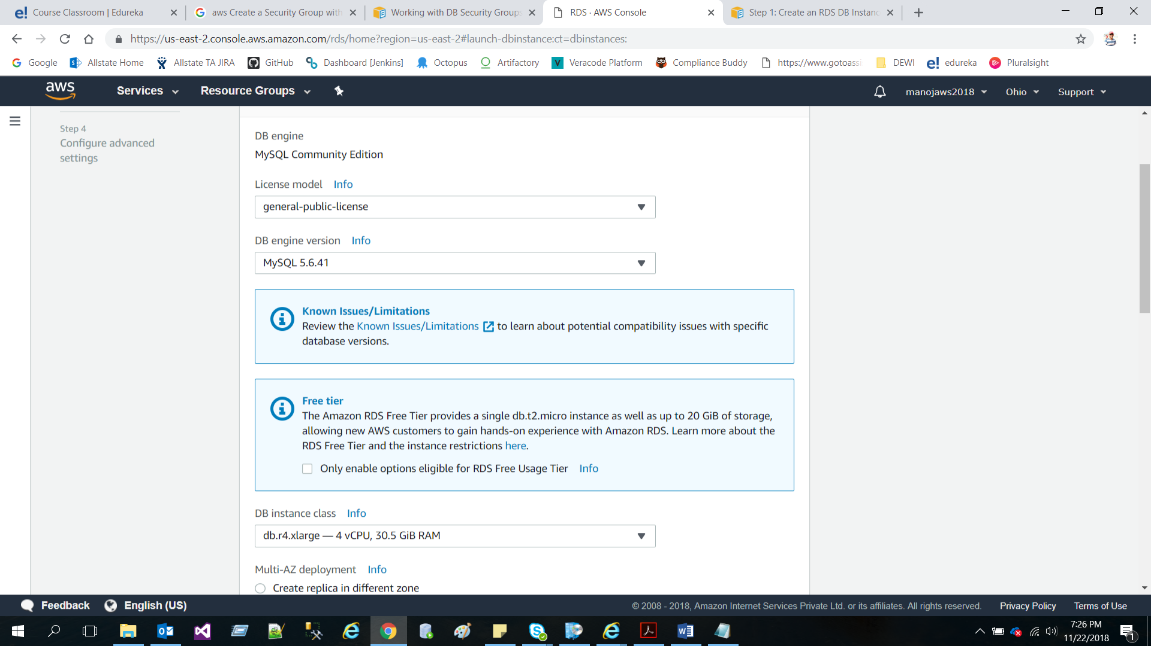

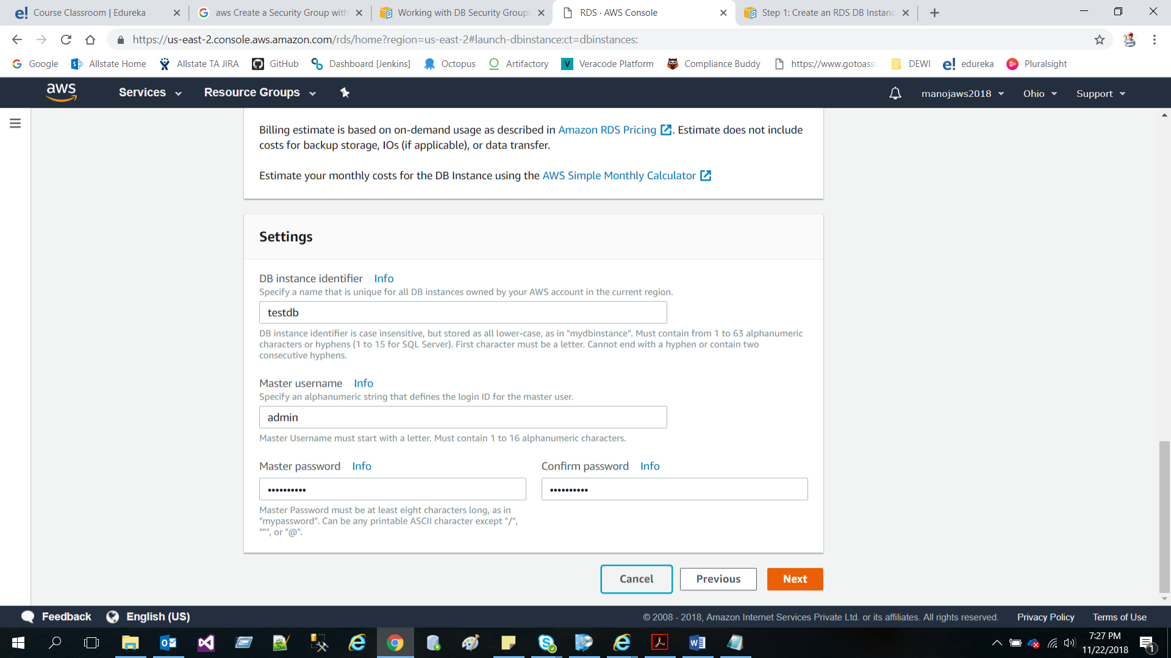

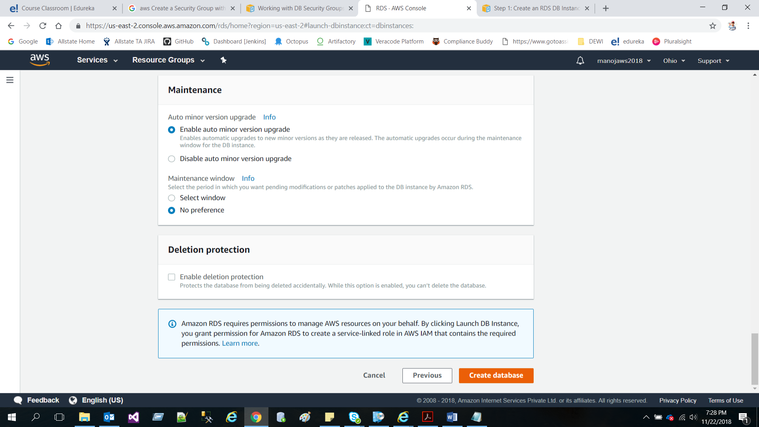

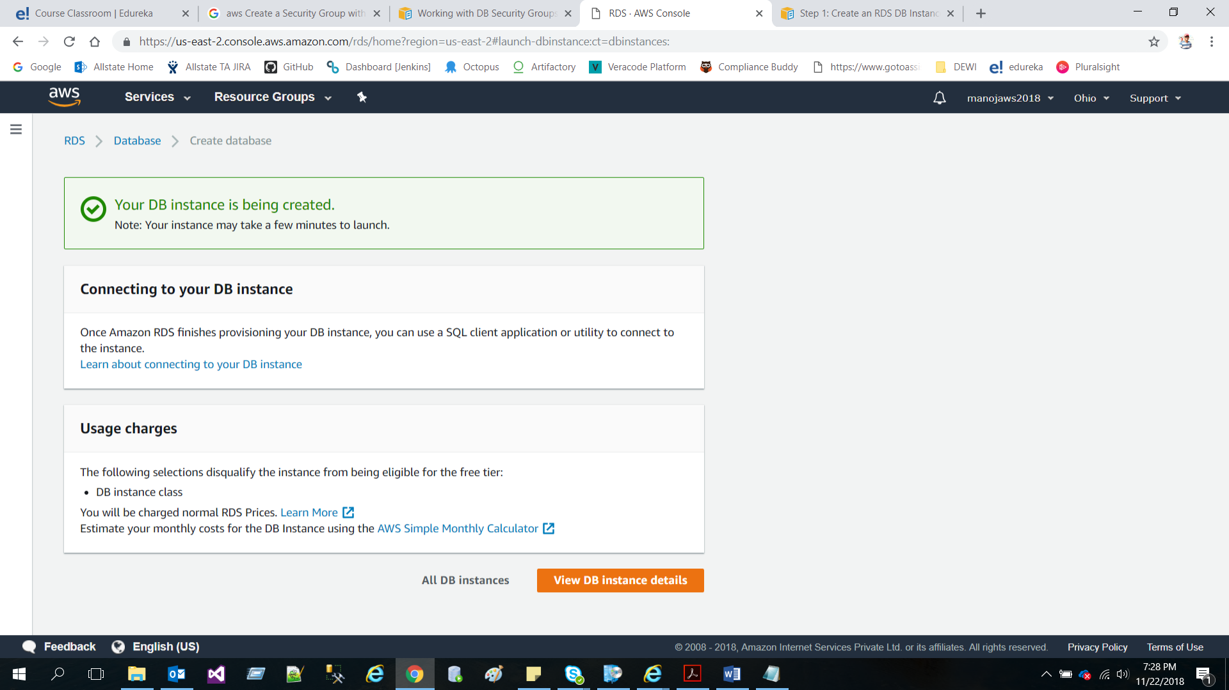

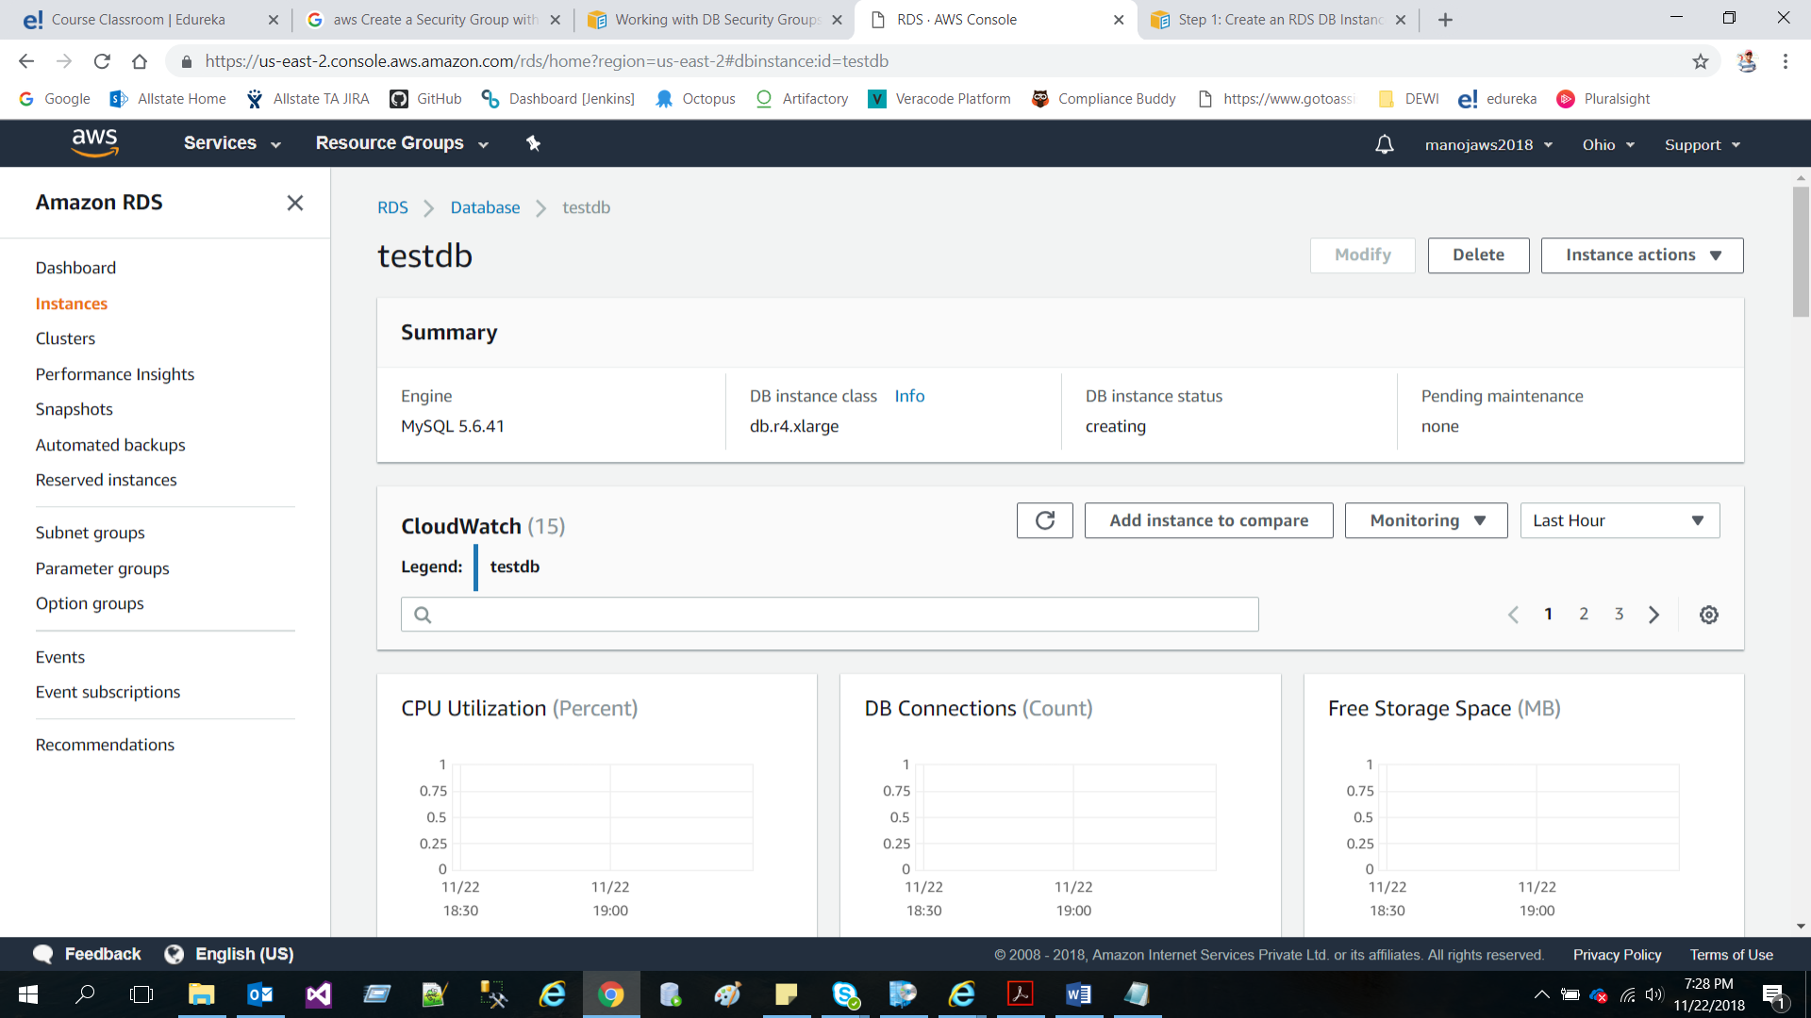

Step 4: Deploy Your App

* 1. • Start your EC2 Instance and install web server. o **Update software packages** - sudo yum update -y
  2. o **Install the Apache web server, PHP, and MySQL software packages** - sudo yum install -y httpd24 php56 mysql55-server php56-mysqlnd php56-mbstring php56-gd php56-opcache
  3. o **Start the Apache web server** - sudo service httpd start
  4. o **Configure the Apache web server to start at each system boot -** sudo chkconfig httpd on
  5. • Install Drupal o Download Drupal - wget https://ftp.drupal.org/files/projects/drupal-7.52.tar.gz
  6. o **Unzip the Drupal package -** tar -xvf drupal-7.52.tar.gz
  7. o **Go to Drupal directory -** cd drupal-7.52/

Project Guide

© B r a i n 4 c e E d u c a t i o n S o l u t i o n s P v t . L t d Page 2

www.edureka.co/cloudcomputing

* 1. o **Create a directory inside the Drupal folder -** mkdir sites/default/files
  2. o **Copy settings.php file** - cp sites/default/default.settings.php sites/default/settings.php
  3. o **Move Drupal to /var/www/html/** - sudo rsync -avh . /var/www/html/
  4. o **Grant ownership of the /var/www directory** - sudo chown -R apache /var/www
  5. o **Open the file to edit the properties -** sudo vim /etc/httpd/conf/httpd.conf
  6. o Find the section <Directory "/var/www/html">, and set AllowOverride as follows:
  7. o **Restart http Server -** sudo service httpd restart
* • To validate the result, open the browser and enter the public IP address of an instance in the address bar.
* • Configure Drupal with Standard profile
* • Test the website.

**As my machine is office machine I can’t connect into EC2 instance as my company VPN is not allowing to connect AWS instance outside our office network.**

Step 5: Scale and Load-Balance Your Web App within your VPC

* Configure an Auto Scaling group

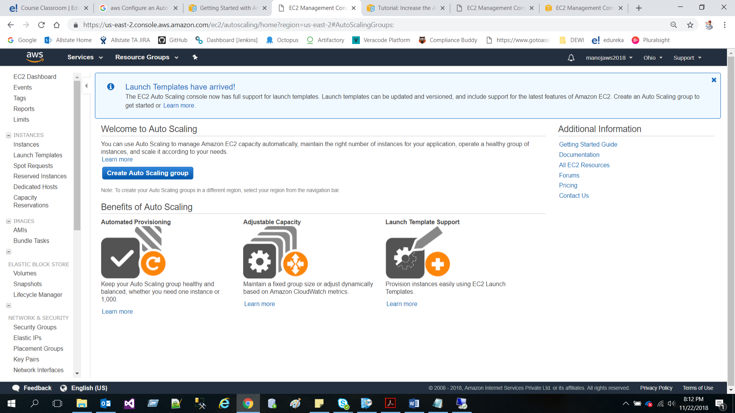

* Create an application load balancer

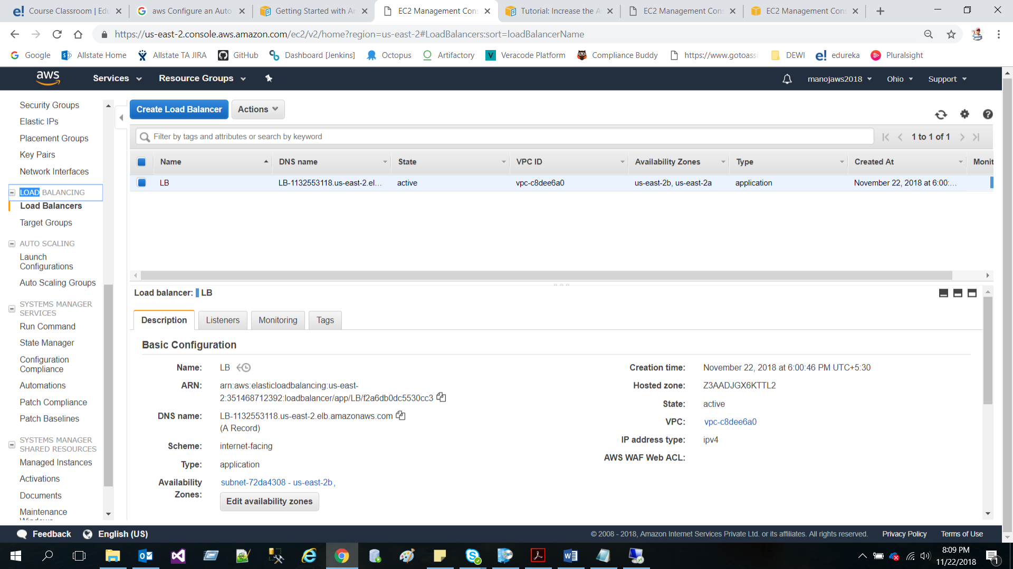

* Test your Load Balancer

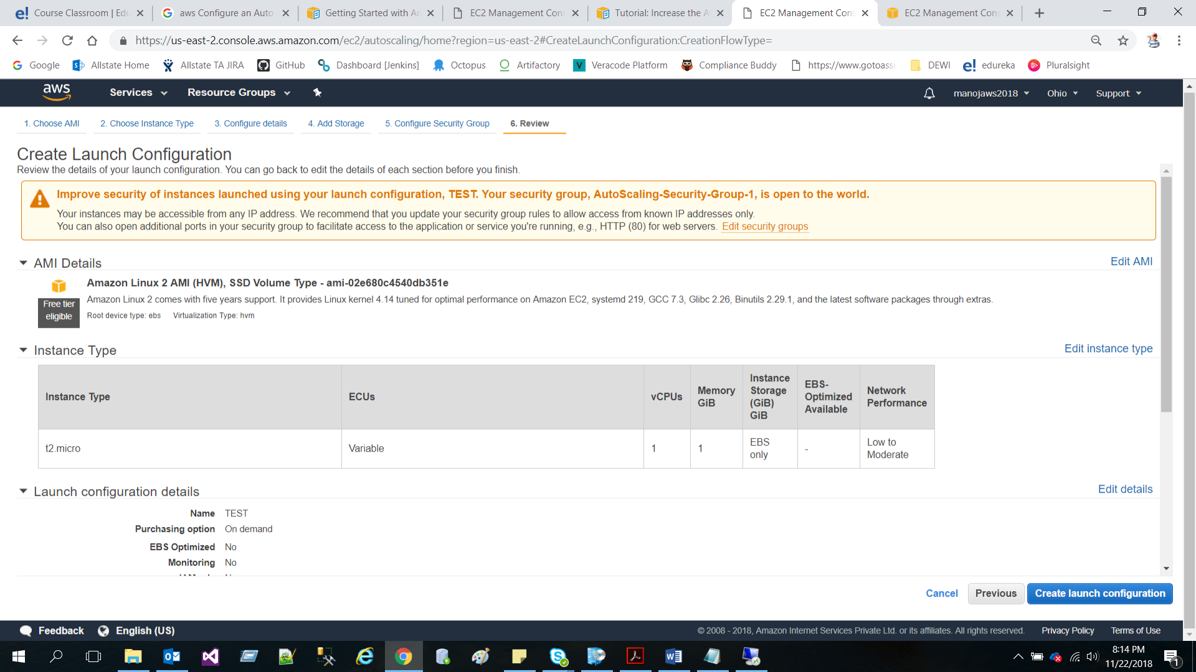

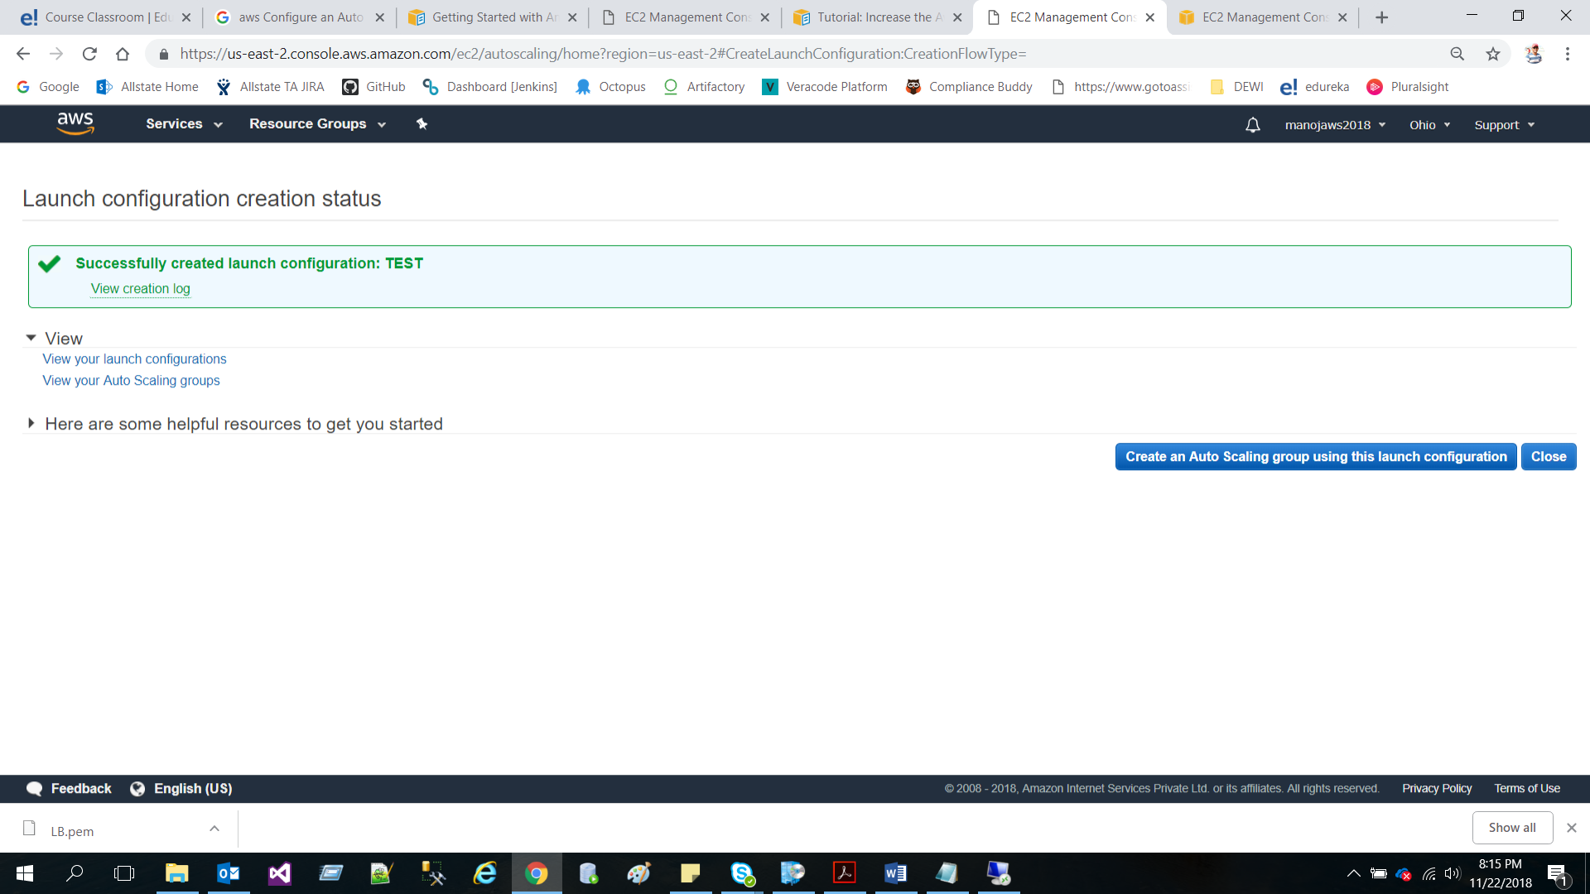

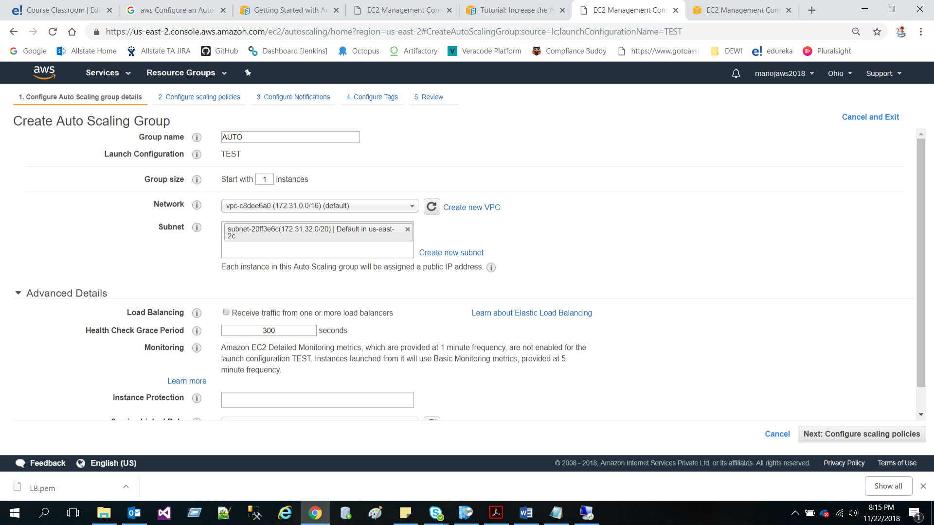

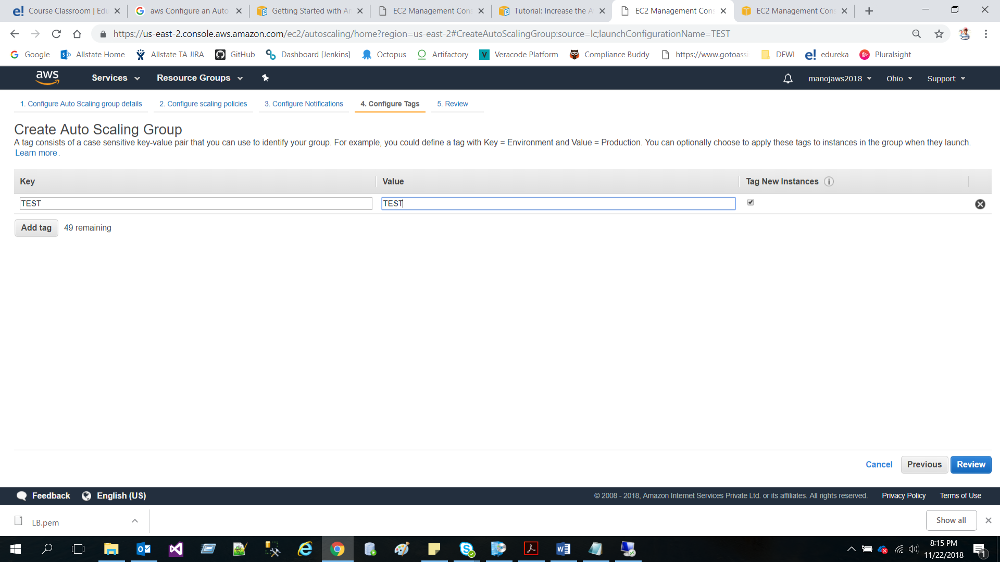

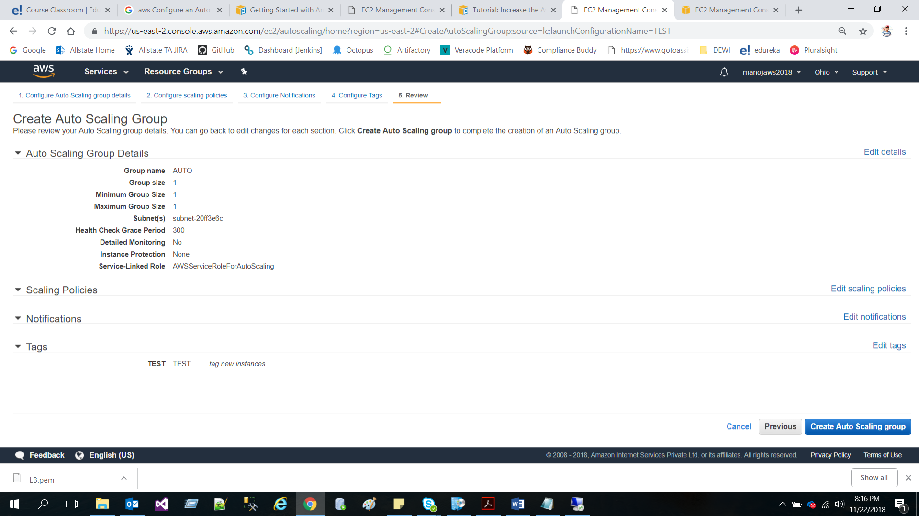

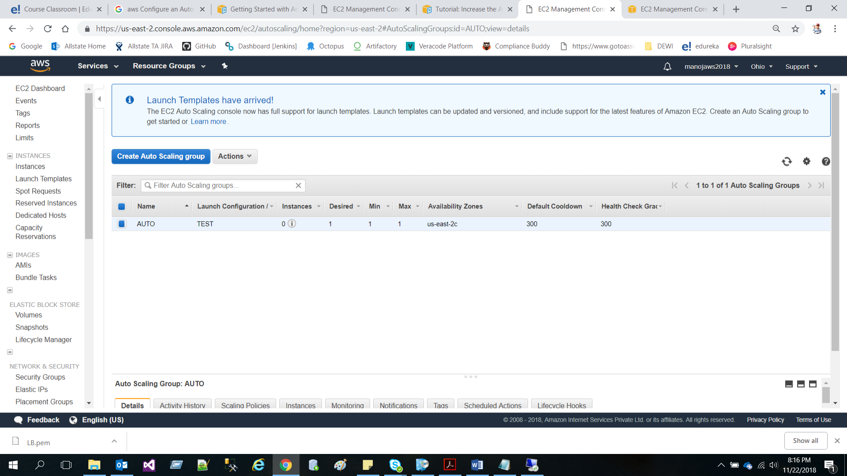

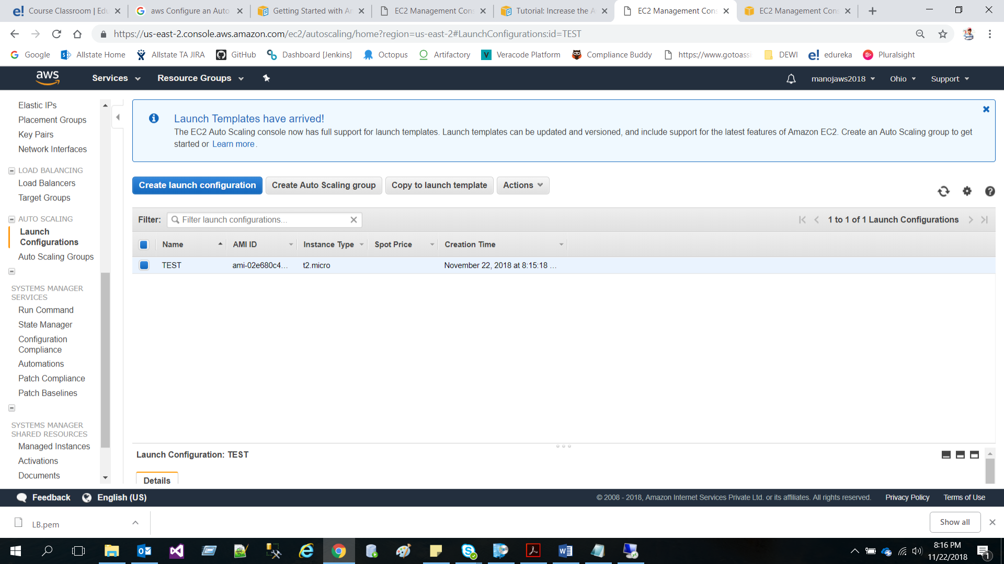

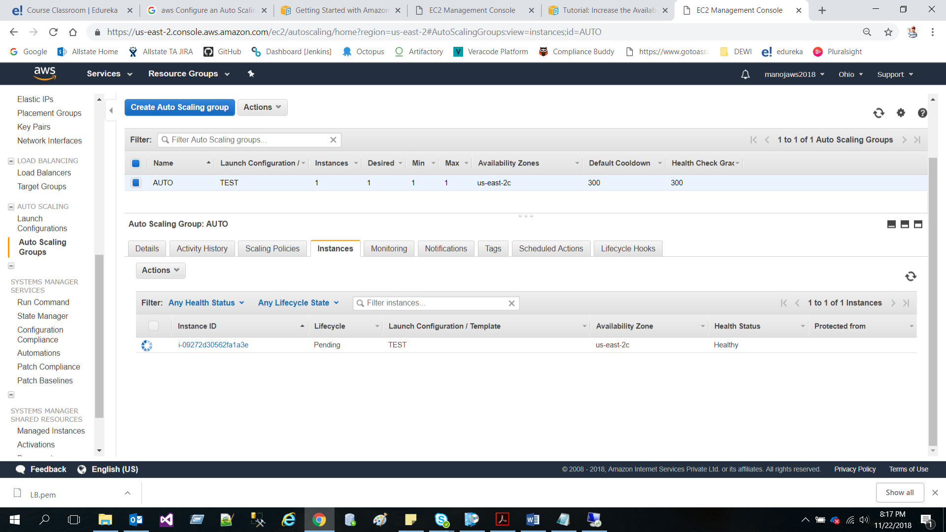

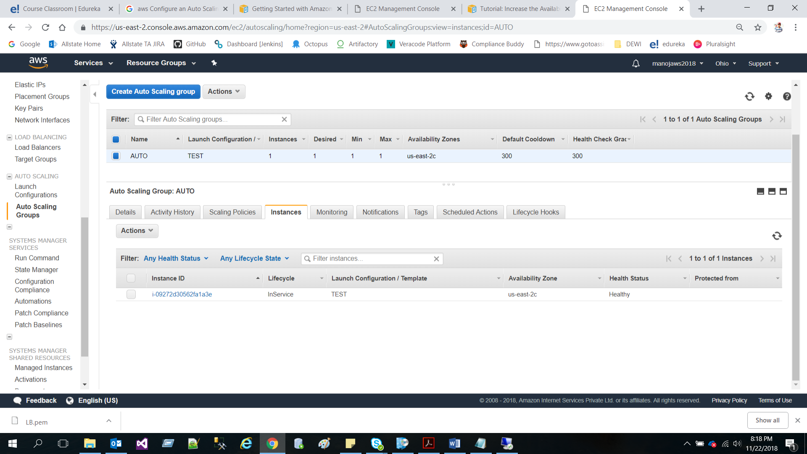

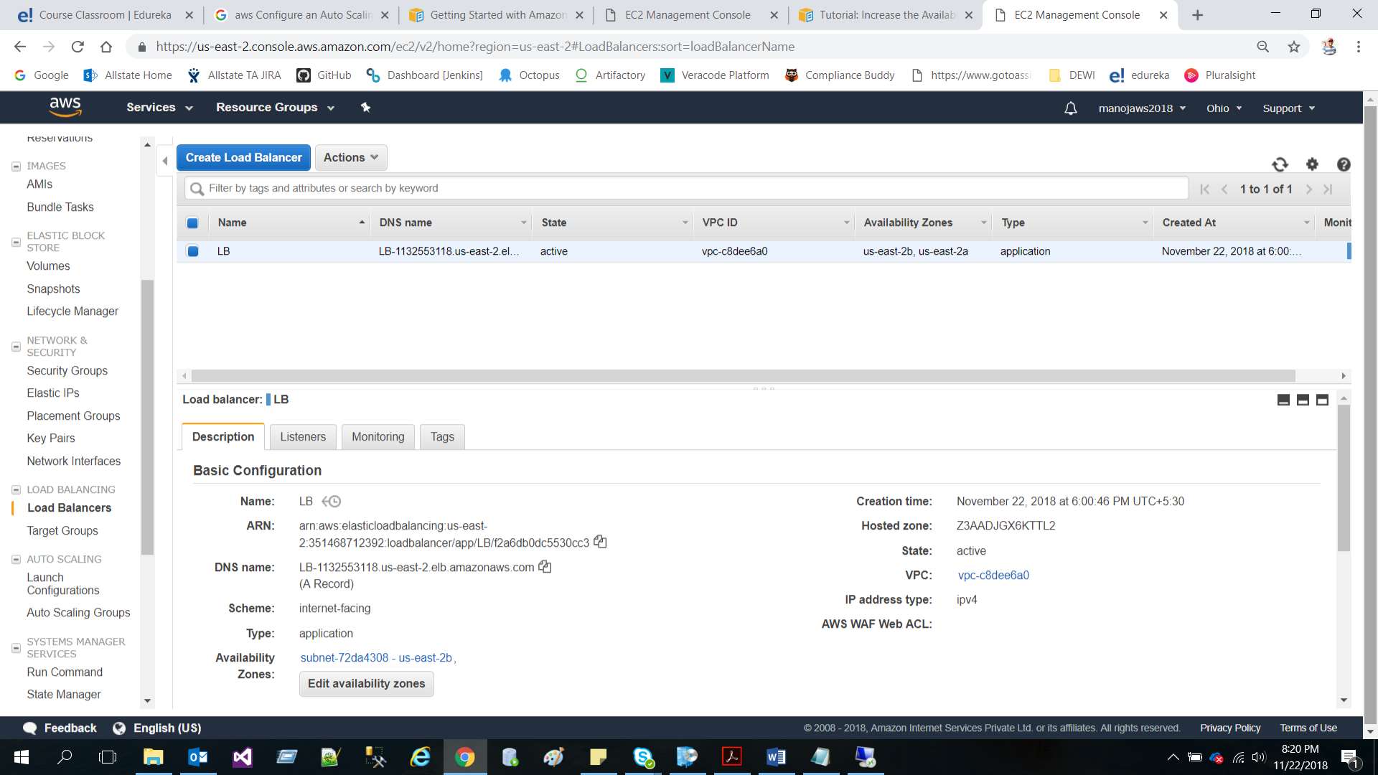

Step 6: Associate a Domain Name with your website

* Register a Domain Name with the help of Route 53

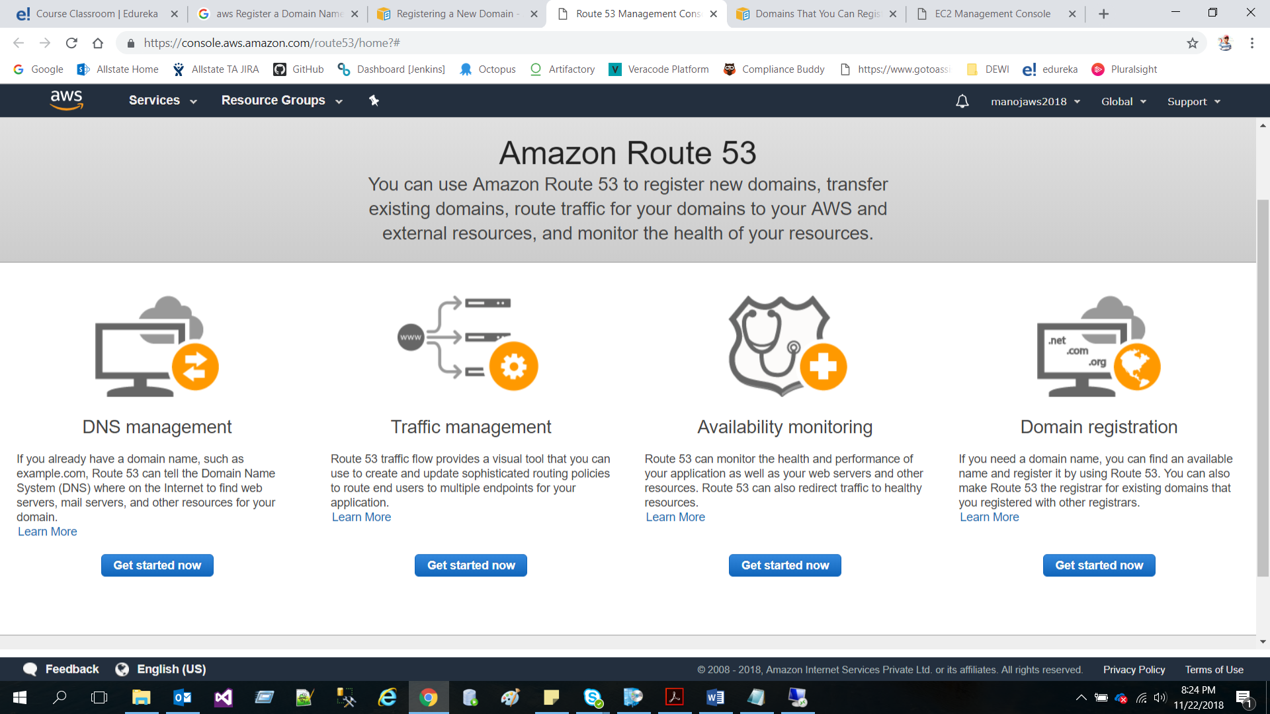

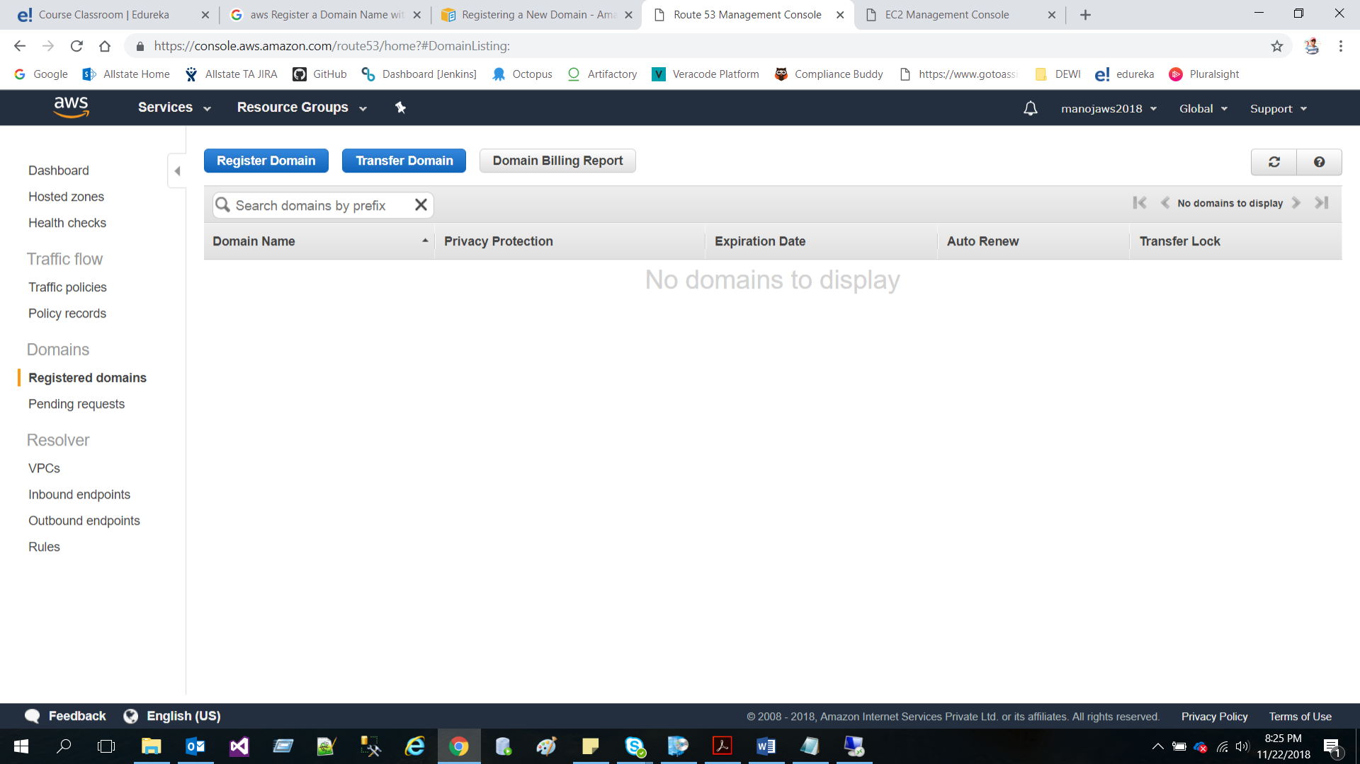

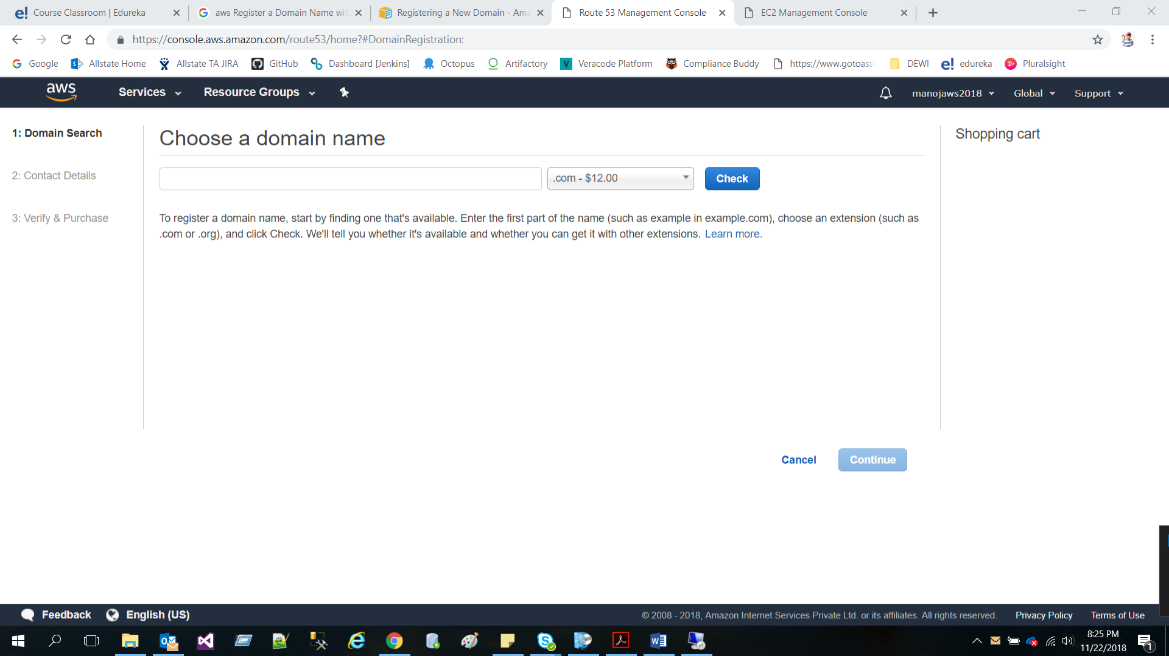

**As domain is paid amount, I can’t create a new domain**

* Create a Hosted Zone for your Domain

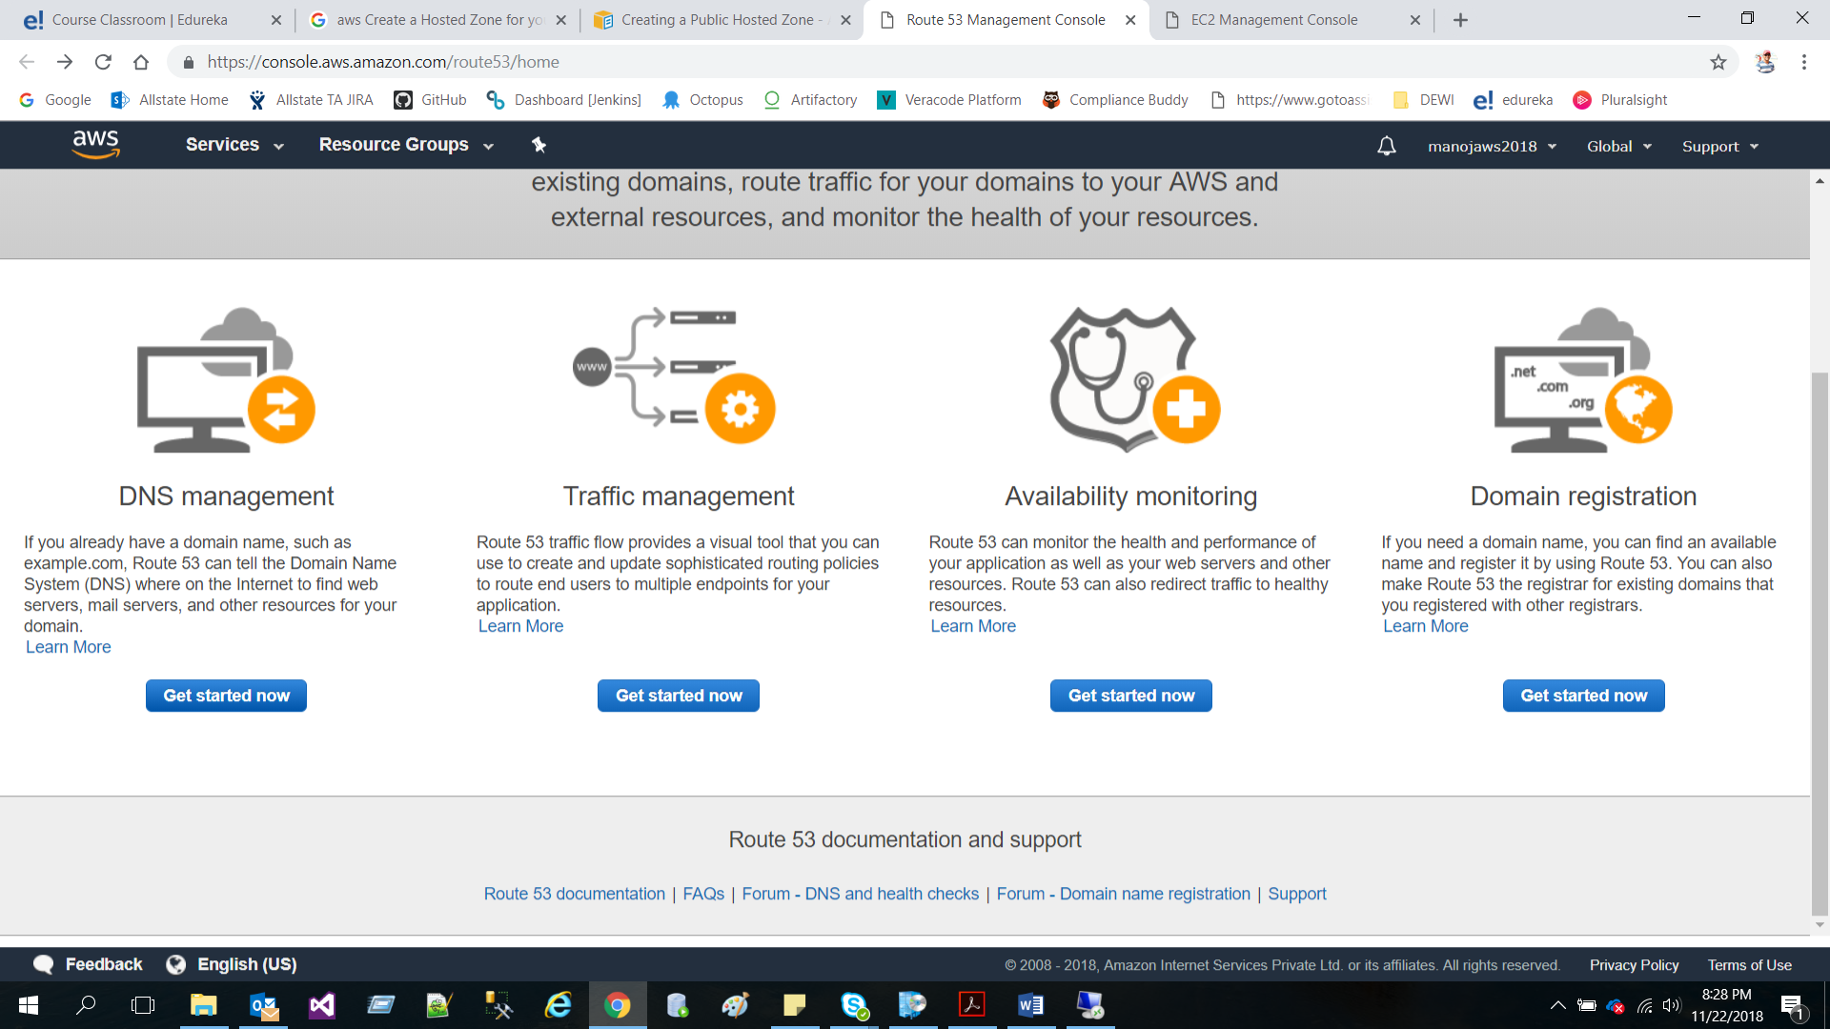

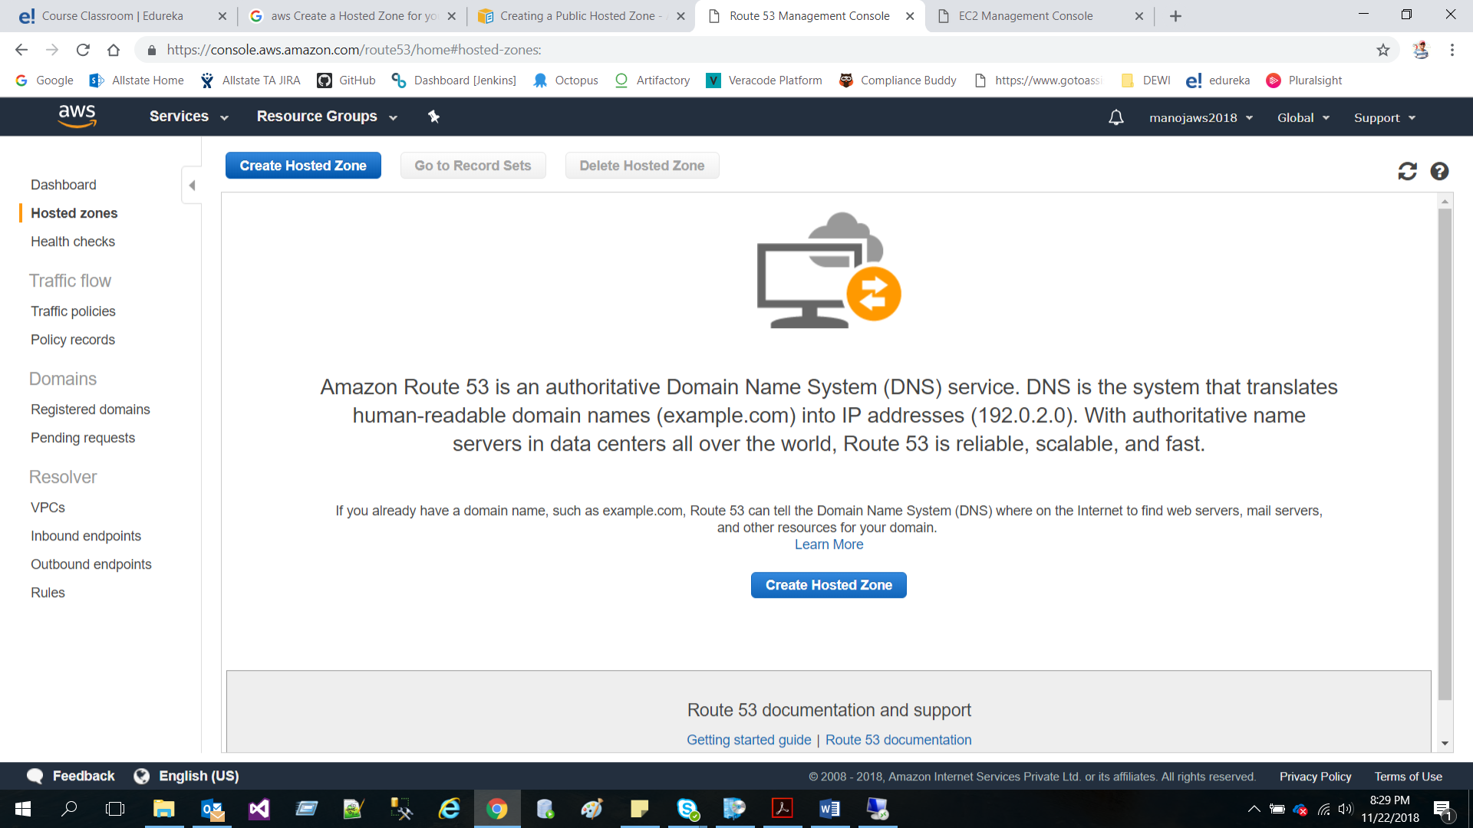

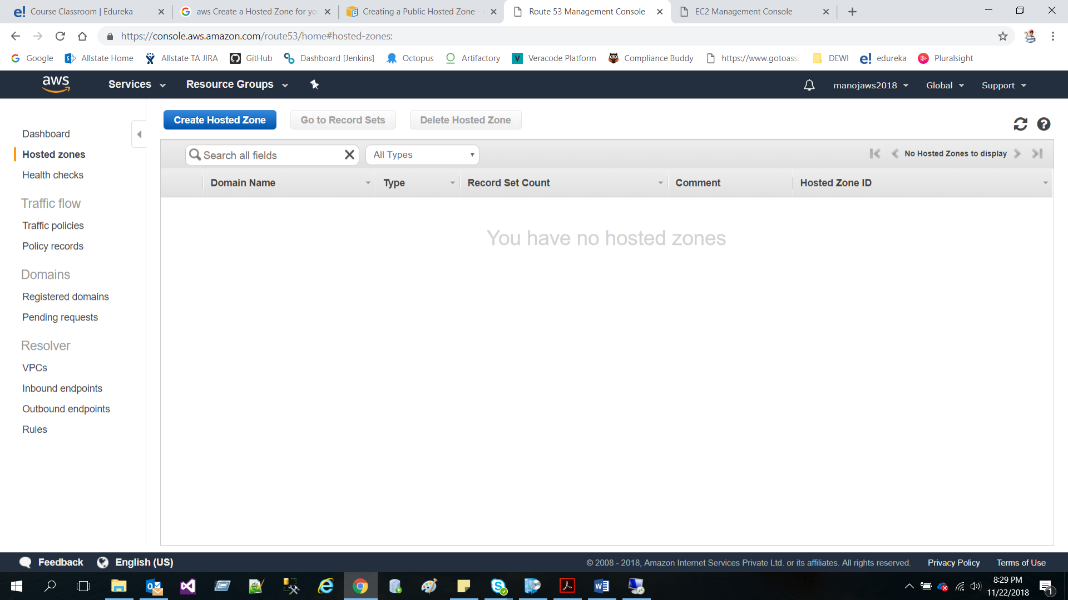

**As domain is paid amount, I can’t create a new domain**

* Create Resource Record Sets for Your Domain and Subdomain

**As domain is paid amount, I can’t create a new domain**

* Set Up a DNS Provider

**As domain is paid amount, I can’t create a new domain**